Record of the Coaching Session

Coach:
Coachee:
Coaching Session date:

Review of Progress against your goals: | Dates/ Key points
Record of Discussion: | Dates/ Key points
Resources used: | Key points

What’s next? New actions/goals | Dates/ Key points
Emotional Check-in. How are you feeling at the end of the session?

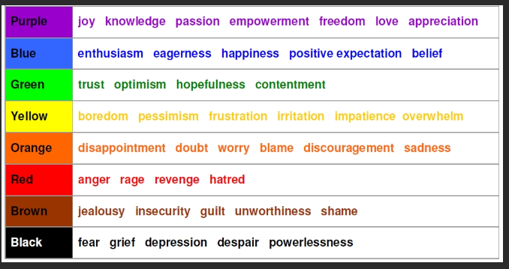

Any further support or actions?

Date of next session:
Signed coach:
Signed Coachee:

The coach should send a copy of the coaching record to the coachee and the end of each session

