Rev1 03/12/18

DWFRS
mentoring Guide

The Mentoring Guide
Please read the Coaching and Mentoring Procedure ED14 in conjunction with this Guide
“A mentor is someone who allows you to see the hope inside yourself.” — Oprah Winfrey
- Introduction

1.1 Mentoring is a direct method of increasing a person’s competence on-the-job and has been defined by the CIPD as “the passing on of support, guidance and advice in the workplace for the benefit of the organisation”. Mentoring tends to describe a relationship in which a more experienced colleague uses their greater knowledge and understanding of the work or workplace to support the development of another member of staff. It could also be a method where a less experienced or confident learner learns the 'tricks of the trade' from a colleague over a longer time.

1.2 Mentoring is used specifically and separately as a form of longer term tailored development for the individual which brings benefits to the organisation. The characteristics of mentoring are:
- It is a supportive form of development.
- It focuses on helping an individual manage their career and improve skills.
- Can be more informal and meetings can take place as and when the mentee needs guidance and/or support.
- More long term and takes a broader view of the person
- Agenda is set by the mentee with the mentor providing support and guidance
- Can be used as part of promotions process or to prepare staff for future role development
- Mentor usually passes on experience and could be more senior
- Mentors can be more ‘directive’ and provide advice and judgement where appropriate– coaches don’t offer their own advice or solution, but help the individual determine their own actions.

- The Benefits of Mentoring
2.1 Mentoring has a clear and positive effect on the personal and professional
development of the Mentee. It is also intended to benefit the Mentors and the
organisations they work for.
As a Mentee you should expect to:
- Identify areas for development and improve self confidence
- Confront current situations and issues
- Lead the agenda
- Ask the questions you need answers to
- Be prepared to probe rather than accept the first answer
- Increase your understanding about yourself and situations
- Develop and practise your listening skills
- Learn from your Mentor
- Improve job satisfaction, motivation and enhance peer recognition
- Encourage self-reflection and develop specific skills
- Develop work-based objectives to feed into your Personal Review

A mentor does not need formal mentor, trainer or coaching qualifications but is often a person whose experience, “savvy”, knowledge and effectiveness is respected by others.

2.2 The Mentor’s involvement supports a Mentee by:
- Giving them an insight into your work and career
- Assisting them with practical tips on planning a successful job search strategy
- Offering advice and guidance with their career thinking
- Developing understanding, skills and problem-solving support
- Encouraging reflection and recognise and celebrate effective practice
- Identifying areas for development and improve self confidence

3. The Principles of Mentoring
3.1 The “Support” behaviour from our RESPECT framework stresses the importance of all staff supporting development of colleagues – even at the same role level. This can be achieved by an experienced, or competent, member of staff becoming a mentor to another, for example a learner on a formal development programme.
3.2 Whilst Mentoring in the Service is not formally ‘facilitated’ by the Learning and Organisational Development team, the following principles underpin the DWFRS Mentoring approach:

- The mentoring relationship will promote inclusion and reflect our RESPECT behaviours
- The mentee will drive the relationship
- There is a shared understanding of what mentoring involves and agreement to be mentored
- Confidentiality boundaries are agreed and respected
- Any written record produced is appropriate to the needs of the Mentor
- and Mentee, and accessible to both parties
- The mentee and mentor will create a timeframe for the frequency of meetings and for the duration of the relationship.

4. Being a Mentor
4.1 At any time during your career you may be asked to be a mentor. Being a mentor can be both an honour and at the same time a cause of sheer terror. It is an honour because one of the greatest thrills of a generous soul is to quietly help another person become all they can be; good parents after all have been doing it for years. The terror comes from the fear that you might not get it right.

Mentoring is a popular development tool used in a wide variety of organisations. Usually the mentor has more experience in a given field and their job is to guide, coach and empower their partner to achieve more than they would from other types of development opportunity. Whilst the pairing of people might be part of a formal programme, the relationship is often voluntary, and this is often one of its strengths because it is based on trust and is a safe way to develop skills and networks. It is particularly useful in helping a person develop soft skills rather than technical competencies.

One of the most influential writers and thought leaders on how to be a good mentor is David Clutterbuck in the UK. Over the last 30 years he has written extensively on mentoring and coaching. He has used ‘mentor’ as an acronym to describe key elements of the mentoring process:

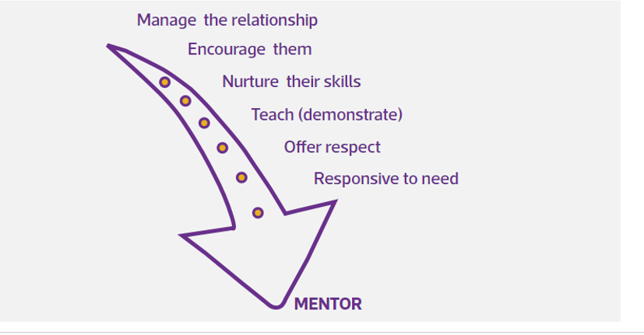
Mentoring may include giving advice, information, establishing facts, sign-posting, self-appraisal, etc. Whatever techniques are used, the emphasis is on enabling and empowering the Mentee to take charge of their own development and their work environment.
To allow this transition the importance of interpersonal skills is essential. These include listening effectively, empathy, understanding a non-judgemental approach and the ability to facilitate through skilled questioning.

“The delicate balance of mentoring someone is not creating them in your own image, but giving them the opportunity to create themselves.” — Steven Spielberg

4.2 Your role as Mentor is to:
- Listen
- be clear and effective when communicating
- establish a relationship and build rapport trust and respect
- Question, to elicit facts
- Share information and knowledge about the organisation, job and informal networks
- Offer different perspectives
- have a flexible approach
- Draw on own experience when appropriate
- assist goal development and setting, including giving feedback
- challenge and give feedback
- bring about understanding, promote action and build resilience.
- Confront and discuss current issues
- Challenge your own assumptions

4.3 and to encourage the Mentee to:
- Listen
- Clarify understanding and share their thinking
- Review and reflect on their career goals
- Challenge their assumptions and consider different perspectives
- Take responsibility for their own development
- Commit to an action plan
- Make decisions to maximise the outcomes of the Mentoring relationship

4.4 As a Mentor involvement will benefit you and DWFRS as mentoring allows you
the opportunity to:
- Develop and practise skills
- Demonstrate your commitment to RESPECT behaviours and inclusion
- Gain a real understanding of diversity issues
- Share the knowledge and experience gained
- Improve job satisfaction, motivation and enhance peer recognition
- Encourage self-reflection and develop specific skills

5. How to request a Mentor
5.1 The Coaching and Mentoring Procedure (ED14) explains that any staff member considering requesting a mentor should:
- read this Mentoring Guide
- complete Mentoring Questions (Form HRXX) and use this to think through their own objectives and needs.
- discuss their needs with their line manager and jointly identify possible mentors

5.2 Because mentoring involves passing on of work-based skills and knowledge the best person to determine an appropriate mentor is the individual staff member in partnership with their line manager.

5.3 Where a possible mentor is identified the staff member(mentee’s) line manager will approach the mentor’s line manager to “sound out” their willingness to be a mentor and check availability and capacity.
The new mentee will then arrange the first meeting with their mentor

6. The Mentoring relationship
6.1 The Mentoring relationship can be a very powerful positive experience. It enables and
develops a greater sense of confidence, enhancing the professional and personal skills
of both parties.

6.2 The following are only a suggestion of activities that Mentors and Mentees may take part
in:
- An initial contracting meeting
- Work shadowing
- Review discussions
- Making use of a Learning Log (see Section 8)
- Building a portfolio or record of achievement
- Personal support
- Reviewing the relationship
- Ending the relationship

7. Setting your goals as a Mentee
7.1 As a mentee you have decided to enter into a mentoring relationship and have a shared responsibility to give time and energy to this. You can develop and improve this relationship by:
Preparation - Think about what your specific needs are in terms of skills, knowledge and support.
These questions may help which have been set out in the Mentor Questions Form (Form HR00):
- I am experiencing difficulty with…
- In terms of support, I may need…
- I want to develop my skill(s) in… What would you suggest?
- Things that have gone well are…
- How can I find out more about…?
- I would appreciate your support and ideas on... etc.

- Clarity – clearly communicating your needs and aspirations to the Mentor will make the meetings focused and both parties will know where they stand.
- Networking – use any contacts and confidential information sensibly, seeking permission from the Mentor when using their name or details
- Future meetings - prepare for your meetings by reflecting on what’s gone well for you in the past week/month, new work goals or objectives, and behaviours you could stop, start or continue.
- Take action – completing agreed tasks within the negotiated time frames

“One of the greatest values of mentors is the ability to see ahead what others cannot see and to help them navigate a course to their destination.” — John C. Maxwell

- Using a Learning Journal
8.1 Finally, one way to ensure you are able to reflect on clear issues is to use some form of learning log, journal or diary system. A learning journal system allows you to review situations and it is through this process you learn, develop and more importantly take ownership of the process. You can then, reflect, recognise achievements, analyse practices and identify areas for development. Some of the common questions, which may be used to help the Mentee reflect, are:
- What have I achieved?
- What have been difficult areas when...?
- What analysis has come from?
- What have I learned from...?
- What do I need to change so I can...?
- What do I need to develop to allow me to...?

Things to include and remember when you use a learning journal:
- Reflection key learning points
- Support and development needs – be specific
- Difficulties that were encountered and how they were resolved
- Strengths Achievements and successes

8.2 Remember that the learning journal is there as a tool to support your development
and needs only be shown to those who have contracted into the Mentoring programme.

8.3 For any help or to answer any queries please refer to the Coaching and Mentoring Procedure ED14 or email the Learning & Organisational Development team.

“If I have seen further it is by standing on the shoulders of giants.” — Isaac Newton

Source: Chartered Institute of Personnel and Development (CIPD)

