Bristol, North Somerset & South Gloucestershire (BNSSG)

ICS People Committee

Terms of Reference
Document Control
Version | Date | Author/Reviewer | Comment
0.1 | 30.08.22 | Julie Bacon
0.2 | 02.02.24 | Louise Carthy | Review and draft refresh
0.3 | 05.03.24 | Louise Carthy | Additions to membership
0.4 | 02.04.25 | Jo Hicks & Georgina Hawkins | Review, refresh and updated Governance structure.
0.5 | 11.04.25 | Georgina Hawkins | Confirmed with JH to remove ICB Chief Medical Officer as Chief Nurse represents both and to remove Sirona Chief People Officer as a voting member and into attendance.
0.6 | 11.06.25 | Georgina Hawkins | Confirmed changes to People Governance Structure with Jo Hicks and implemented.

Approved by:
Version | Date | Group | Status
0.1 | 07.09.22 | ICS People Committee | Approved
0.3 | 27.03.24 | ICS People Committee | Approved

- Introduction
The ICS People Committee is established by the BNSSG Integrated Care Board (ICB) as a Committee of the Board in accordance with its Constitution.
These terms of reference, which must be published on the ICB website, set out the membership, the remit, responsibilities, and reporting arrangements of the Committee and may only be changed with the approval of the Board.
The ICS People Committee is a non-executive committee of the Board.

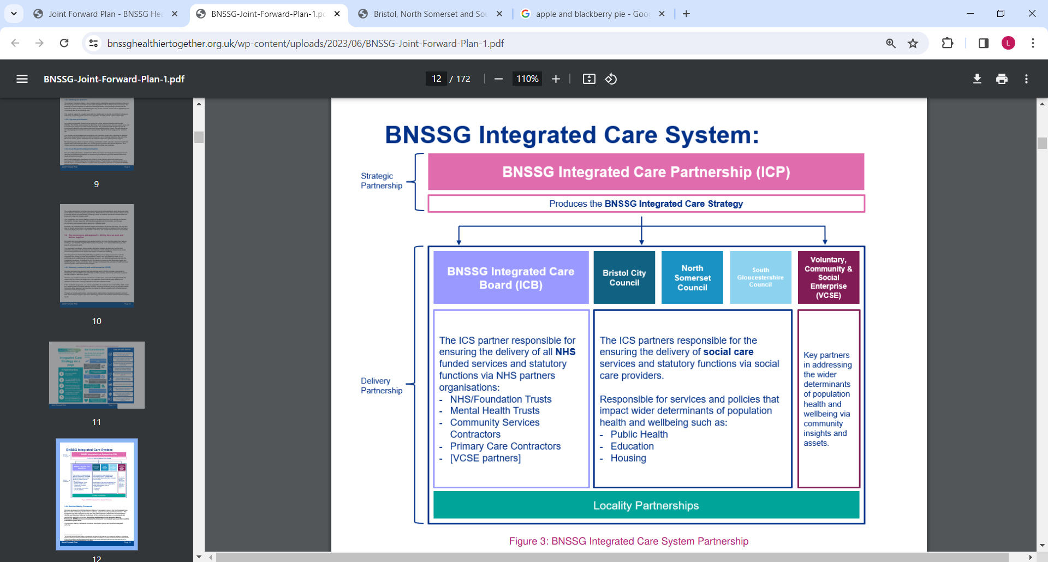

- Purpose
The purpose of the ICS is to:
- improve outcomes in population health and healthcare
- tackle inequalities in outcomes, experience and access
- support broader social and economic development
- enhance productivity and value for money
The purpose of the ICS People Committee is to support and enable our Integrated Care System workforce of 50,000 people to feel safe, valued and supported in their roles, to enable them to deliver improved health and wellbeing outcomes for our 1,000,000 citizens in Bristol, North Somerset and South Gloucestershire.
The ICS People Committee supports the collective aims and ambitions of the ICS Strategy (published June 23) and our local response to the NHS Long Term Workforce Plan, by providing oversight and assurance to the Board on the adequacy and delivery of the BNSSG People Programme approach.

- Role of the ICS People Committee
What the ICS People Committee is | What the ICS People Committee is not
- An official assurance committee.  - Accountable to the ICB Board.  - An official governance mechanism with formal sign off capability.  - A system-wide committee with collective responsibility for providing assurance on the BNSSG People and Culture agenda. | - A delivery group.  - A planning group.  - A public committee.  - A forum for ideas exploration.

- Delegated Authority
The ICS People Committee is authorised by the Board to:
- Deliver its purpose as set out in these terms of reference.
- Investigate any activity within its terms of reference.
- Seek any information it requires within its remit, as outlined in these terms of reference.
- Commission any reports it deems necessary to help fulfil its obligations.
- Obtain legal or other independent professional advice and secure the attendance of advisors with relevant expertise if it considers this is necessary to fulfil its functions. In doing so the committee must follow any procedures put in place by the ICB for obtaining legal or professional advice.
- The committee may not delegate any of its accountabilities to sub-groups.

- Remit and Responsibilities
The duties of the ICS People Committee are as follows:
- Monitor development, seek assurance and make recommendations to the ICB Board on matters relating to workforce, people and culture, and their implementation across the system.
- Agreement of the formal governance and accountability arrangements for People and Culture activities and functions in the ICS, including appointing senior responsible officers (SROs).
- Ensure there is appropriate trade union and provider engagement with the ICS People Programme.
- Oversight and assurance on how and where specific People responsibilities are delivered and funded within the ICS.
- Receive updates from members on progress of People Committee activities within partner organisations.
- Hold providers and SROs to account for delivery on agreed priorities.
- Assuring the delivery of the 10 People Functions of an ICS which may change but currently include:
      - Supporting the health and wellbeing of all staff
      - Growing the workforce for the future
      - Supporting inclusion and belonging for all
      - Supporting leadership at all levels
      - Educating, training and developing people, and managing talent
      - Leading workforce transformation and new ways of working
      - Driving and supporting broader social and economic development
      - Transforming people Services
      - Leading coordinated workforce planning
      - Supporting system design and development
- Oversee the assessment of the ICS’s readiness, capacity, and capability to deliver its People and Culture activity.
- Ensure there is a clear understanding of the ICB and system strategic workforce priorities and that plans are in place to deliver these.
- Provide assurance that legislative and regulatory requirements relating to workforce are understood and met.
- Challenge and scrutinise risks relating to the People and Culture agenda, ensuring they are understood and that mitigating actions are identified and implemented.
- Monitor key workforce metrics to ensure that the expected standards are being delivered.
- Provide assurance to the ICB Board on equality and diversity activities, and equality delivery systems.

- Membership
Members of the ICS People Committee shall be appointed by the ICB Board in accordance with the ICS Constitution.
Chair and Vice-Chair
In accordance with the Constitution, the Committee will be chaired by a Non-Executive member, appointed on account of their specific knowledge, skills and experience making them suitable to chair the Committee. Committee members may appoint a Vice Chair from amongst the Non-Executive members.
In the absence of the Chair and Vice-Chair, the remaining members present shall elect one of their numbers to Chair the meeting.
The Chair will be responsible for agreeing the agenda and ensuing matters discussed meet the objectives as set out in the Terms of Reference.
Attendees
Only members of the ICS People Committee have the right to attend Committee meetings, however the Chair may invite relevant staff to the meeting as necessary in accordance with the business of the Committee. The Chair of the ICB Board will be invited to attend. The Chair of the ICB Board will not be a voting member.
Meetings of the ICS People Committee may also be attended in full or in part by individuals “in attendance”, who are not members of the Committee, as and when appropriate. The Chair may ask any or all of those who normally attend, but who are not members, to withdraw to facilitate open and frank discussion of particular matters.
Other individuals may be invited to attend all or part of any ICS People Committee meeting as and when appropriate, to assist the Committee with its discussions on any particular matter.
The membership of the ICS People Committee shall include:
Voting Member | Organisation
Non-Executive Member (Chair) | ICB
Non-Executive Member - addition | ICB
Chief People Officer | ICB
Chief Nursing Officer | ICB
Non-Executive Member / Chair of People Committee | UHBW
Non-Executive Member / Chair of People Committee | NBT
Non-Executive Member / Chair of People Committee | Sirona
Non-Executive Member / Chair of People Committee | AWP
Primary Care representative / Transformation and Strategy – Executive Director | One Care
ICS Local Authority Partner | Bristol City Council
In Attendance | Organisation
Chair of BNSSG ICS People Programme Board | UHBW
Chief Executive, Voluntary Action North Somerset | VCSE Alliance
ICS People Programme SROs & Leads
People Programme Officers as required
Community Partner CPO | Sirona

If a voting member of the Committee is unable to attend a meeting, they should notify the ICB People Programme Officer at least one week prior to the meeting. An update on progress of the member’s own People Committee activities must be provided in writing or may be delivered via the voting member’s nominated representative (who shall not have voting rights).
Where an attendee of the Committee (who is not a member of the Committee) is unable to attend a meeting, a suitable alternative may be agreed with the Chair. Suitable alternatives can also attend for members in agreement with the Chair.

- Administration
- Administration support will be provided by the People Programme Officer.
- If members are unable to attend, they must advise the Chair and/or the People Programme Officer and nominate a deputy of sufficient seniority to attend and participate in their place.
- Agenda and papers will be circulated at least 3 working days before the meeting.
- Actions will be circulated within 2 weeks of the meeting.
The Committee shall be supported with a secretariat function. This will include the following:
- Ensuring the agenda and papers are prepared and distributed in accordance with the Standing Orders having been agreed by the Chair with the support of the relevant executive lead.
- Preparing and monitoring attendance lists ahead of meetings to gauge quoracy.
- Recording of members’ appointments and renewal dates, prompting the Committee to renew membership and identify new members where necessary.
- Ensuring good quality minutes are taken in accordance with the Standing Orders and agreed with the chair, and that a record of matters arising, action points and issues to be carried forward are maintained.
- Supporting the Chair to prepare and deliver reports to the Board.
- Ensuring the Committee is updated on pertinent issues / areas of interest / policy developments.
- Ensuring action points are taken forward between meetings.

- Quoracy
For a meeting of the ICS People Committee to be quorate, a minimum of three members of the Committee must be present and must include either the Chair or the Vice Chair.
If any member of the Committee has been disqualified from participating in an item on the agenda, by reason of a declaration of conflicts of interest, then that individual shall no longer count towards the quorum.
If the quorum has not been reached, then the meeting may proceed if those attending agree, but no decisions may be taken.
Decision making and voting:
Decisions will be taken in according with the Standing Orders. The ICS People Committee will ordinarily reach conclusions by consensus. When this is not possible the Chair may call a vote.
Only members of the ICS People Committee may vote. Each member is allowed one vote and a majority will be conclusive on any matter.
Where there is a split vote, with no clear majority, the Chair of the Committee will hold the casting vote.
If a decision is needed which cannot wait for the next scheduled meeting, the Chair may conduct business on a ‘virtual’ basis through the use of telephone, email or other electronic communication.

- Frequency and Governance
The ICS People Committee will meet in private.
The ICS People Committee will meet bi-monthly. Arrangements and notice for calling meetings are set out in the Standing Orders. Additional meetings may take place as required.

- Accountability and Reporting
The ICS People Committee is accountable to the ICB Board and shall report to the Board on how it discharges its responsibilities.
Minutes of ICS People Committee meetings shall be formally recorded by the secretary and submitted to the ICB Board in accordance with the Standing Orders.
The ICS People Committee Chair will provide assurance reports to the ICB Board at each meeting and shall draw to the attention of the Board any issues that require disclosure to the Board or require action.
Delivery will be through the BNSSG People Programme Board which will be accountable to the ICS People Committee.
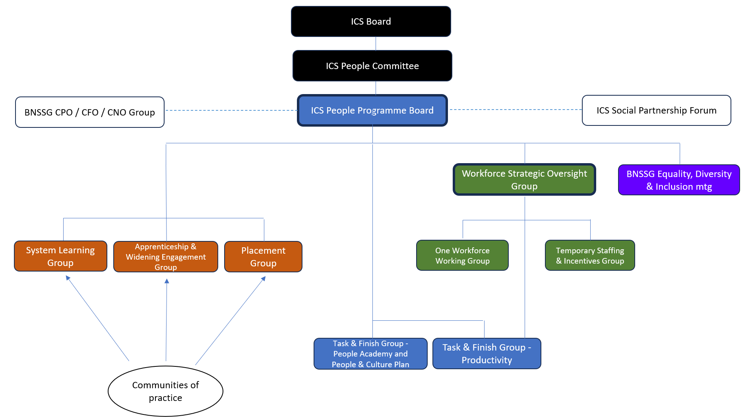

- Behaviours and Conduct
Benchmarking and guidance
The ICS People Committee will take proper account of national guidance, best practice and appropriate benchmarking.
ICB values
Members will be expected to conduct business in line with the ICB values and objectives and the principles set out by the ICB.
Members of, and those attending, the Committee shall behave in accordance with the ICB’s constitution, Standing Orders, and Standards of Business Conduct Policy.
Equality diversity and inclusion
Members must demonstrably consider the equality, diversity and inclusion implications of decisions they make.

- Conflicts of Interest and Decision Making
The ICB Corporate Team will maintain a schedule of Declarations of Interests. ICS People Committee members are required to declare any interests and to notify the ICS People Programme Officer of any changes to interests as they arise. The schedule will be available to all members on request.
Members will be required to declare relevant interests verbally at the start of a meeting and, at the Chair’s discretion, they may be asked to leave the meeting while a particular topic is being discussed. Conflicts of Interest will be considered case by case with the Chair.

- Confidentiality
All documentation shared in the ICS People Committee is considered confidential and will not be shared outside the group without the specific consent of the contributing member.
The closed minutes of the ICS People Committee are shared with the Committee for information and comment and are not to be shared with organisational colleagues until ratification at the next meeting.
The open minutes of the ICS People Committee are shared with the ICB Board for information and are therefore in the public domain.

- Review and Approval
The ICS People Committee will review its effectiveness at least annually.
These Terms of Reference will be reviewed at least annually and earlier if required. Any proposed amendments to the Terms of Reference will be submitted to the ICB Board for approval.

11/04/25

