Review of the role of Locality Partnerships in BNSSG: Partner responses to the final report

Forum: BNSSG Integrated Care Partnership Board 27th February 2025

Author: South Gloucestershire Locality Director (Kirstie Corns)
Version: V.1.0 FINAL 15.02.2025

Purpose of Paper
The purpose of this paper is to:

- summarise ICP Board member organisation responses to the final report and recommendations of the review of the role of Locality Partnerships in BNSSG (Appendix 1).

- Set out a recommendation to align Locality Partnership development with the anticipated developments at both national and local level including:

  - NHS 10-Year Health Plan (due to be published in May 2025)

  - Neighbour Hood Health Guidelines

  - The Fuller Stocktake (and the development of Integrated Neighbourhood Teams)

  - The BNSSG Healthier Together 2040 (HT2040) approach

- set out a recommended governance structure and process by which the BNSSG System would develop and agree their strategic vision for the function, role and responsibilities of System (1), Local Authority (3), Place and Neighbourhood (6) including Primary Care Networks (20) and the emerging Integrated Neighbourhood Teams within this policy context.

- propose senior System Leadership and accountability for the onward development of this work.

Background
In June 2024, the BNSSG Integrated Care Partnership Board commissioned an independent report into the role of Locality Partnerships in BNSSG. The report was jointly funded by BNSSG Integrated Care Board, Bristol City Council, North Somerset Council and South Gloucestershire Council.

A cross-system, co-produced Terms of Reference was implemented to guide the review, and its purpose was to answer the following question:

What does the BNSSG System require of Locality Partnerships to contribute to the successful delivery of:

- The BNSSG Integrated Care System Strategy
- The BNSSG Healthier Together 2040 Service Plan

Oliver & Company UK Ltd. were appointed as independent consultants to lead the review on behalf of the BNSSG Integrated Care Partnership Board. Responsibility for oversight of the review process was delegated to the newly established BNSSG Locality Partnership Review Core Group chaired by the South Gloucestershire Locality Director.

Over the course of three months (August-November 2024) an independent review of the current and future role of Locality Partnerships was undertaken. This involved widespread System engagement through:

- The multi-organisation LP Review Core Group which was established to oversee and guide the review.

- 6 in-person half-day workshops held in September and October.

- Key stakeholder interviews conducted.

- Two online surveys made available for people unable to attend workshops.

- Tailored online survey to PCN Clinical Directors and GP Collaborative Board Locality Leads.

- Attendance at stakeholder meetings e.g. GP Collaborative Board, BNSSG ICB Exec Team, ICP Board, LP Collaborative Operational Delivery Group, Care & Support West Board.

The final report and recommendations of the ‘Review of the role of Locality Partnerships in BNSSG’ was presented to the BNSSG Integrated Care Partnership Board on the 28th of November 2024.

Board Members:

- Committed to taking the recommendations through individual organisational governance for feedback by 31st December 2024.

- Approved the recommendation for the Locality Partnership Review Core Group to remain in place for a further three months to collate feedback following the ICP Board discussion and organisational discussions, and develop an implementation plan, including governance arrangements, on behalf of the ICP Board and that membership of this group would be reviewed over this time.

- Approved the recommendation that the Locality Partnership Review Core Group would collate feedback on the report and proposals within it for mobilisation of the recommendations and provide an update and recommendations for next steps to the following ICP Board Meeting 27th February 2025.

Learning
Following the publication of the final report and recommendations, the Locality Partnership Review Group reflected on the review process and identified points of learning:

- Earlier identification and clarification of senior strategic leaders’ vision for Locality Partnerships may have steered the review to deliver more detailed, ambitious recommendations for the function of Place-based partnerships within BNSSG.

- It is not possible to review and define a single component of complex Systems in isolation. The LP Review Group noted the tension between adhering to the agreed Terms of Reference (Appendix 2), and the ever present need to broaden the scope and consider the totality of System infrastructure.

- The changing strategic context, and anticipated national guidance around neighbourhood, place and the shift of treatment and care to community, constrained many System partners’ ability to fully engage with the review. There was a concern that this work may be premature and that there was a risk we may need to repeat the exercise upon publication of policy and guidance.

- The short timeframe for the review limited the diversity of stakeholders who were able to engage in the review. This was particularly relevant for senior strategic leaders who require greater advance notice to attend in-person workshops.

Changing strategic context

4.1 National context
In the 5-month period between the ICP Board’s commission of the Locality Partnerships Review (June 2024), and the presentation of the final report and recommendations (November 2024), the external strategic and political context in the UK changed significantly. Most notably, the results of the general election on 4th July 2024, which saw the appointment of a Labour government following 14 years of Conservative held office.

Since September 2024, several health and social care related government white papers, independent reviews and guidance have been published:

Month | Publication / announcement
September 2024 | Independent Investigation of the NHS in England (12th September 2024)  The Rt Hon. Professor the Lord Darzi of Denham
October 2024 | NHS 10-Year Health Plan  Department for Health & Social Care
November 2024 | Keeping Children Safe, Helping Families Thrive: Breaking down barriers to opportunity (18th November 2024)  Department for Education
December 2024 | English Devolution White Paper​: Power and partnership: Foundations for growth (16th December 2024)  Ministry of Housing, Communities & Local Government  Children’s Wellbeing and Schools Bill (18th December 2024)  Originated in the House of Commons, Session 2024-25
January 2025 | Independent review of adult social care: Development of a National Care Service (starting April 2025*)  Department for Health & Social Care  Neighbourhood Health Guidelines 2025/26 (29th January 2025)  NHS England  2025/26 priorities and operational planning guidance (30th January 2025)  NHS England

*Due to report recommendations in two phases: mid-2026 and 2028 respectively. The work forms part of a wider package of support for the sector, which includes more funding for elderly and disabled people to make home improvements and stay out of hospital.

4.2 Policy analysis
There are common themes emerging from these recent policy announcements, the majority of which align with the BNSSG Integrated Care System Strategy and its 5 Opportunities:

- We need to tackle inequalities

- We can strengthen the building blocks of good health and wellbeing

- Wherever possible, we need to prevent illness and treat people earlier

- We need to work alongside communities to support healthy behaviours

- And once people are ill, there are conditions that we could manage better.

Identified commonalities include:

1. Decentralisation and Local Empowerment
A prominent theme is the shift of power and decision-making from central authorities to local entities. The English Devolution White Paper emphasises transferring authority to local governments, enabling them to tailor services to their communities' specific needs. This approach is mirrored in the Neighbourhood Health Guidelines 2025/26, which advocate for integrated care boards and local authorities to collaboratively plan and deliver health services at the neighbourhood level.

2. Integration of Services
Integrating health and social care services is a recurring focus. The Neighbourhood Health Guidelines 2025/26 promote a model where multidisciplinary teams work together to provide comprehensive care, aiming to reduce fragmentation and improve patient outcomes. Similarly, the Children's Wellbeing and Schools Bill calls for a drive for improvements for better join-up between children’s social care, police, and health services with education and more integrated working, shared identification of risk and proactive work around early intervention, prevention, and family help.

3. Prevention and Early Intervention
Prevention and early intervention are central to all these policies. The anticipated NHS 10-Year Plan is expected to focus on shifting care from hospitals to communities, supporting early interventions to prevent health deterioration. This preventive approach is also evident in the Children's Social Care Reform Bill, which aims to support families proactively to prevent issues from escalating.

4. Community Engagement and Participation
Involving communities in decision-making processes is highlighted across these documents. The English Devolution White Paper advocates for empowering local communities, recognising that local leaders are best positioned to understand and address their area's unique challenges. The Neighbourhood Health Guidelines 2025/26 also stress the importance of involving local communities in planning and delivering health services to ensure they are responsive and effective.

5. Addressing Health Inequalities
Reducing health inequalities is a shared objective. The Neighbourhood Health Guidelines 2025/26 aim to create healthier communities by providing better care close to or in people's homes, and addressing the wider, social determinants of health. The NHS 10-Year Plan is anticipated to further this goal by focusing on preventive care and early intervention, particularly in underserved communities.

4.3 The concept of neighbourhood
The recently published Neighbourhood Health Guidelines states that ‘The approach to establishing integrated neighbourhood teams has been well defined in the Fuller Stocktake’. (‘Next steps for integrating primary care: Fuller Stocktake Report, May 2022). Fuller introduces the concept of Integrated Neighbourhood Teams (and teams of teams) describing them as:

…… bringing together previously siloed teams and professionals to do things differently to improve patient care for whole populations.

This is usually most powerful in neighbourhoods of 30-50,000, where teams from across primary care networks (PCNs), wider primary care providers, secondary care teams, social care teams, and domiciliary and care staff can work together to share resources and information and form multidisciplinary teams (MDTs) dedicated to improving the health and wellbeing of a local community and tackling health inequalities.

Integrated neighbourhood ‘teams of teams’ need to evolve from Primary Care Networks (PCNs) and be rooted in a sense of shared ownership for improving the health and wellbeing of the population. They should promote a culture of collaboration and pride, create the time and space within these teams to problem solve together, and build relationships and trust between primary care and other system partners and communities.

The Neighbourhood Health Guidelines sets out 6 initial core components associated with an effective neighbourhood health service but does not specify or mandate its form.

Appendix 1, section D states that INTs should ‘…. deliver proactive, planned and responsive care, and prioritise care based on individual people’s needs and the opportunity for greatest impact. Footprints should be designed to optimise neighbourhood working and partnership with local authorities.’

A recent NHS Confederation report ‘The state of integration at place’ (November 2024) notes that ‘Defining ‘place’ is complex, as it varies in meaning across the health and social care sector. While perhaps challenging, this malleability is crucial. Thriving Places, a guidance document produced by the Local Government Association (LGA) and NHS England, states: “The footprint of place should be based on what is meaningful to local people, has a coherent identity and is where they live their lives – such as a town, city, borough or county.” This could mean many things depending on local context…’

Therefore, this paper concludes that the guidance provided is deliberately permissive and that Systems have the mandate to define neighbourhood as they deem appropriate for their population and its communities (mirroring the 2022 Health & Care Act approach to defining Place).

4.4 Local context
Locality Partnerships were established in BNSSG in 2017, followed by the inception of Primary Care Networks in 2019 and Sirona Integrated Network Teams in 2020 (Appendix 6). 2024 saw the creation of the BNSSG VCSE Alliance to enable VCSE organisations to engage with the health and care system at a strategic level to create positive change and develop a sustainable third sector to support delivery of the ICS Strategy.

The below diagram sets out the national requirements against the maturity of the BNSSG System. The opportunity for BNSSG lies in the strategic integration and connection of the component parts of our existing neighbourhood health infrastructure. This would create the foundation for a BNSSG neighbourhood healthcare, social care and wellbeing operating model (and align with feedback from system partners for a greater level of ambition for Place).

BNSSG has almost ten years’ experience of integrated partnership working at place and neighbourhood. The maturity of our approach is evident when compared with the 10-year vision set out in the Neighbourhood Health Guidelines 2025/26. This paper recommends that we build on this strong foundation, taking confidence from the strategic alignment of our local approach with national policy.

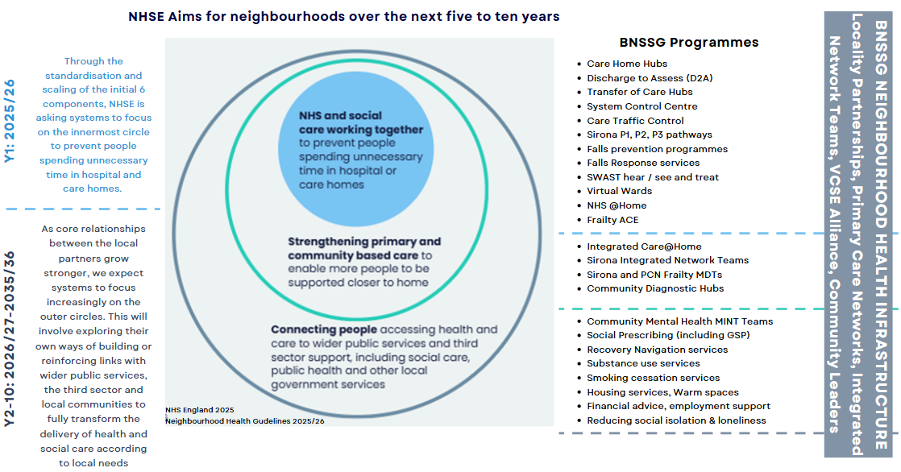

Partner feedback

5.1 Summary of feedback
Formal feedback was received from all BNSSG ICP Board member organisations (Appendix 5), with all Partners expressing their broad support for most of the recommendations. They also highlighted the time, energy, resource and structural alignment that partners have committed to the six Locality Partnerships over recent years.

Whilst some partners responded directly to each of the recommendations, the majority did not and cited the following reasons:

- Unable to respond / form an opinion as the report did not set out a vision and a core purpose for Place-based partnerships in BNSSG.

- Recommendation did not directly impact their organisation (e.g. funding arrangements for core LP Teams).

- Other (not specified).

Partners expressed disappointment that the review focussed on mechanistic elements of the Locality Partnerships (e.g. structures, processes, governance) rather than the complex adaptive space that is system working.

Partners highlighted the conflict between the desire to be more ambitious and the continuous reduction of the Locality Partnership Teams over recent years. Partners also noted the unintended consequence of recent financial mitigations which have reduced the ability of general practice to be actively involved in the leadership of neighbourhood and place.

There is a collective desire to clearly and quickly agree a framework for how we determine what we do at System (1), Local Authority (3), Place (6) and PCN (20) and neighbourhood, informed by the cultural successes of the Locality Partnerships’ ‘bottom up’ approach. Partners were keen that we design the framework through ‘doing’ and move away from ‘discussion’ to ‘mobilisation’.

5.2 Positively received recommendations
The recommendations that the partners most engaged with and directly supported were:

- Align the BNSSG Integrated Care System (ICS) Strategy with the three Health & Wellbeing Strategies.

- Strengthen connection to the ICB Board and System Executive Group (SEG). Appoint SEG members to be sponsors for different Locality Partnerships.

- BNSSG Integrated Care Partnership Board, Integrated Care Board and System Executive Group to clarify how they want future arrangements and integrated care culture to develop.

- Clarify roles and ambitions for delegating authority and local investment in prevention.

- Formal reporting of Locality Partnerships’ work via the three Health & Wellbeing Board reports at the BNSSG Integrated Care Partnership Board.

This paper recommends that the BNSSG ICP Board formally accepts and mobilises the recommendations listed above.

5.3 Negatively received recommendations
The recommendations that most partners rejected were:

- Make efficiencies by establishing a Central Support Team resourced from identified talent in all partner organisations.

- Direct links between Central Team to System-wide Boards e.g. workforce, estates, finance, IM&T.

Partners expressed concern that establishing a central team ‘felt like a step backwards in having a shared endeavour’, and their preference would be to explore how existing teams and resources could be more formally aligned to support Place-based working (noting that financial investment requires advanced notice and is dependent upon organisations’ medium term financial plans).

This paper recommends that the BNSSG ICP Board formally rejects the recommendations listed above.

5.4 Spectrum of opinion
There were opposing views amongst partners concerning the progress and direction of this work. At the extreme ends of the spectrum, there was a conflict between partners who wanted to:

- pause / slow this work and wait for national guidance before proceeding (e.g. 10-year plan, Integrated Neighbourhood Teams) and

- those who felt strongly that we have the correct infrastructure in place via the Locality Partnerships and VCSE sector to deliver the shifts from sickness to prevention and hospital to community, and that delays would be unnecessary (and risk disengagement amongst partners).

This paper recommends that the BNSSG ICP Board discuss the spectrum of opinion at the February meeting (noting that thinking has evolved considerably since submission of the feedback, and a greater level of alignment has emerged).

Recommendations and next steps

This paper recommends creating time and space for our system to align the Locality Partnership Review and next steps, with the anticipated developments at both national and local levels including:

- NHS 10-Year Health Plan (due to be published in May 2025).

- Neighbourhood Health Guidelines

- The Fuller Stocktake (and the development of Integrated Neighbourhood Teams).

- the BNSSG Healthier Together 2040 approach.

These pieces of work should not be treated as separate entities and must be considered, designed and mobilised collectively. This would allow for more radical thinking with regards the structures and functions at a system, local authority, place and neighbourhood level.

This paper recommends that an outcomes-based approach is taken to defining the function, role and responsibility of the component parts of our System. This will mitigate the risk of spending a disproportionate length of time debating the static role of each component and recognises that in complex systems roles and responsibilities need to be flexible. The August 2024 Literature Review on Neighbourhood Working from the NHS Confederation and PPL provides a useful process for this undertaking.

This paper also recommends drawing on the work already undertaken in BNSSG to design such a framework. This includes joint work from 2022 with NHS England, the Local Government Association and the ICB (Appendix 4) and the output from the LP Review Phase 1 workshops September 2024, where stakeholders worked through real-life scenarios and mapped out the proposed functions of System, Place and Neighbourhood (Appendix 7).

The Locality Partnership Review is an evolution of the BNSSG ICS Strategy. As such, this paper recommends that the ICP Board charges the ICB Board with mobilising the next steps.

Recommended next steps include:

- appointing a SEG Senior Responsible Officer to oversee this work.

- allocating a senior manager to mobilise this work.

- agreeing the governance for this programme of work and consider how the Health & Wellbeing Boards could support this work.

- agreeing a space for thinkers to come together to consider the totality of this work (e.g. BNSSG Strategic Network).

- closure of the current Locality Partnership Review Core Group, and the set-up of a refreshed group to develop next steps and a system-wide plan to implement a BNSSG Neighbourhood health, social care and wellbeing system.

This paper recommends that the ICP Board receives a progress report on this programme from the ICB Board no later than June 2025.

BNSSG Integrated Care Partnership Board action required: DECISION.

This paper asks the BNSSG Integrated Care Partnership Board to:
- Approve the introduction of formal reporting of Locality Partnerships’ work via the three Health & Wellbeing Board reports at the BNSSG Integrated Care Partnership Board.

- Approve the recommendation to align the following programmes of work:

  - Locality Partnership review and next steps.
  - NHS 10-Year Health Plan (focussing on the ‘3 shifts’ until publication).
  - Development of Integrated Neighbourhood Teams (Neighbourhood Health Guidelines and the Fuller Stocktake).
  - Healthier Together 2040 approach.

- Approve the recommendation to charge the ICB Board with mobilising the next steps of this programme of work as set out in section 6 of this paper.

- Approve the recommendation to receive a progress report from the ICB Board no later than June 2025.
Appendices

Appendix 1
Review of the role of Locality Partnerships in BNSSG Phase 3: Final report and recommendations 28th November 2024 (Oliver & Company UK Ltd.).

Appendix 2
Review of the role of Locality Partnerships in BNSSG: Terms of Reference July 2024.

Appendix 3
Review of the role of Locality Partnerships in BNSSG Phase 1: Desk-Based Analysis report September 2024 (Oliver & Company UK Ltd.).

Appendix 4
Place Development Programme – BNSSG Integrated Care System (LGA, NHSE, ICB)

Appendix 5
List of partners who formally responded to the final report and recommendations:
- Avon & Wiltshire Partnership (AWP)
- BNSSG Integrated Care Board
- BNSSG VCSE Alliance
- Bristol City Council
- Care & Support West
- GP Collaborative Board
- Locality Partnership Collaborative Operational Delivery Group
- North Bristol Trust (NBT)
- North Somerset Council
- Sirona Care & Health
- South Gloucestershire Council
- South Gloucestershire Health & Wellbeing Board
- University Hospitals Bristol & Weston Trust (UHBW)

Appendix 6
Sirona Care & Health Out of Hospital Care Model (2020) including Locality Hubs and Integrated Network Teams.

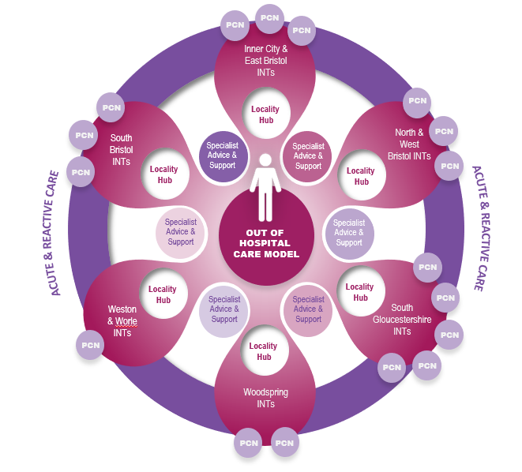
Appendix 7
Output of BNSSG LP Review Phase 1 workshops: proposed functions of System, Place and Neighbourhood (September 2024).
System | Locality Partnerships (Place) | Neighbourhood
Set strategy, vision & ambition  - Set the ICS strategy, advocating and supporting BNSSG and local delivery.  - Healthier Together 2040 – set strategic priorities.  - Be clear about our values and the way we lead – it’s about transformation.  - Listen to localities about what they think the priorities should be  - Be more than a delivery board and set the agenda.  - Find ways to be brave.  Champion innovation  - Provide space for developing understanding for commonalities and differences across LP/LA areas.  - Ensure we have thinking space.  - Support enablement of 'speed boats'(LPs) – doing things with agility.  Deliver strategic enablers  - Resolve workforce and estates issues.  - Digital – enable joined up systems.  - Set legal frameworks/governance.  - Move funding strategically- re-allocate existing resources (not just about money).  - Provide the critical resource for the localities to run.  - Implement sensible commissioning arrangements so they do not damage relationships.  - Set up a VCSE Alliance Brokerage Framework  - Help support fair allocation across different parts of the system inc. wider use than health i.e. prevention, policing and education.  - Ensure effective back-office functions e.g. purchasing.  - Could have a score card as to what a healthy / well performing Locality looks like? Are people showing up? Are they delivering outcomes?  - Provide Locality Partnerships with guidance but also the room to manoeuvre  - Bid for big funding streams  - Ensure economies of scale e.g. specialist services  Unblock the path to success  - Unblock issues for LPs  - The ICP would need to give permission to the individual organisations to work in Locality delivery model.  - Representing us regionally and nationally  - Facilitate the left shift from hospitals to communities  Set the standards and share the knowledge  - Share best practice and innovation across BNSSG – knowledge exchange.  - Receive reports on the 6 as well as the 1 and the 3  - ICP to always consider with every decision – what are the means of prevention?  - NHS and Social care services and VCSE delivered at Place makes sense (all delivery partners).  - Consider how would we make the data and insights flow.  - ICP has no line of sight about what's happening in those places. It's important that ICP knows what happens in LPs  - Be accountable and hold localities to account. | Strategic link between System & Neighbourhood  - Hold the priorities of ICB, JSNA, VCSE, LA and HWB.  - Broker relationship between ICB and VCSE.  - Influence the system upwards – be more collegiate.  Identify local need  - Start from Localities to understand the problem we are trying to solve.  - Understand local demand and what local people are saying- wider than health.  - Engage with local people through co-design and co-production  Convene partnerships  - Form collaborative partnership with all stakeholders to enable effective place-based working.  - Help people to recognise every organisation (especially health) has to shift in some way.  - Recognise the challenge leaders have.  - Broaden membership and funding streams so future is less dependent on NHS monies i.e. joint bids, pooled budgets.  Vehicle for integration  - Would like LPs to be the architecture for delivery of Health & Social Care. Sirona should be in LPs, social care should be in LPs.  - All our providers should be delivering at Localities level and delivering a health system as a Locality health system. It's the right kind of size. Why couldn’t we organise delivery in Localities?  - Deliver and enable integrated care  - Have delegated responsibility and budget for delivery of priorities at local level.  - Be a load-bearing organisation to avoid a lot of work being wasted e.g. Leg Club.  - Deliver quick wins and be given the capital to do all the things they want to do.  - Maximise the role of primary care.  Shift to the left  - Focus on prevention and inequalities  - Facilitate the left shift from hospitals to communities  - Enable and commission VCSE to deliver | Delivery  - Have the energy to create and operationalise change.  - Implement public health initiatives.  - Establish Integrated Neighbourhood Teams.  - Develop VCSE grass roots infrastructure.  - Deliver integrated care.  - Respond flexibly and be agents for change.  Community connection  - Identify community and share local knowledge.  - Connect and share community assets.  New ways of working  - Practise trusted leadership- decide who will lead on work.  - If we’re getting it right, we won’t have the metrics to show it’s going wrong.  Shift to the left  - Focus more on prevention and early intervention.

Appendix 8
Carnall Farrer one-page summary of the NHS England Neighbourhood Health Guidelines
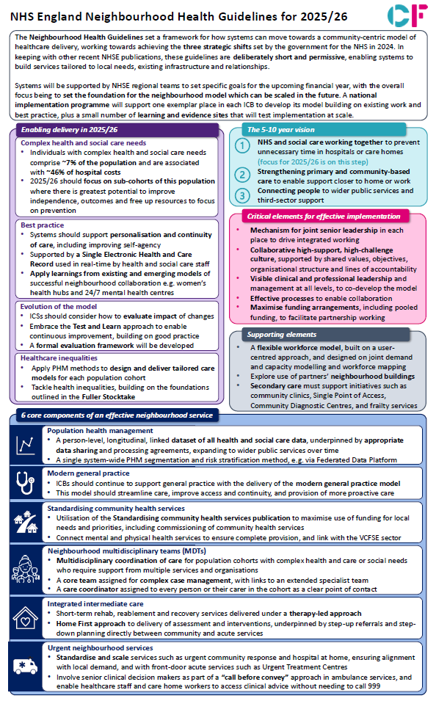

Independent investigation of the NHS in England - GOV.UK
Keeping children safe, helping families thrive
English Devolution White Paper
Children’s Wellbeing and Schools Bill - Parliamentary Bills - UK Parliament
NHS England » Neighbourhood health guidelines 2025/26
NHS England » 2025/26 priorities and operational planning guidance
Integrated Care System Strategy - BNSSG Healthier Together
*Microsoft Word - FINAL 003 250522 - Fuller report[46].docx
The state of integration at place | NHS Confederation
PowerPoint Presentation
NHS England Neighbourhood Health Guidelines for 2025/26 - CF

