Health and care research that makes a difference to those who need it most

NHS Bristol, North Somerset and South Gloucestershire Integrated Care Board Research Strategy 2025-28

Table of Contents

Executive summary 3
Acknowledgements 5
Introduction 6
Background 7
Research within an integrated care board 7
How research participation improves outcomes 8
The virtuous circle 9
The BNSSG ICB research team and what they do 11
Current research activity in BNSSG ICB 12
The problem this strategy aims to address 14
How we developed this strategy 15
BNSSG ICB Research Strategy 2025-2028 17
Strategy on page 18
Vision 19
Aim 21
Pillar 1: Targeting the greatest needs 23
Pillar 2: Radically diversifying health and care research 25
Pillar 3: Developing partnerships at every level 27
Pillar 4: Accelerating research into practice 30
Pillar 5: Generating resources for the ICS 32
Pillars in practice 35
Monitoring 36
Conclusion 38
References 39

Executive summary

BNSSG Healthier Together strategy identifies 5 opportunities for improving health, we need to:
- Tackle inequalities
- Strengthen the building blocks of good health and wellbeing
- Wherever possible, we need to prevent illness and treat people earlier
- Work alongside communities to support healthy behaviours and once people are ill,
- Support people to manage conditions better

Recently the Darzi report (2024) highlights numerous areas for improvement in health and care and concludes that these improvements will take many years. As a response the government has published 3 Big Shifts that will drive the NHS 10-year plan, to be released in 2025. The 3 Big Shifts are:
- hospital to community
- analogue to digital
- sickness to prevention
These are all complex challenges that will require thorough exploration, understanding and innovation. Research is an ideal approach for addressing complex and long-standing challenges.
BNSSG ICB has established itself as a leading ICB for research activity, supporting both the development and delivery of population health and community-based health and care research. Our aim is to create and deliver health and care research that makes a difference to those who need it most.
This strategy presents how we can utilise research as a mechanism to bring enhanced skills to bear on our ICS challenges, secure external funding to increase the investment in the health of our population, whilst improving staff experience and well-being across our workforce.
This strategy identifies the factors that currently limit the impact of our research and sets out five Strategic Pillars that will grow our research portfolio, increase the evidence skills across our ICS and better realise the benefits of research for our system and our population.
The five Strategic Pillars will create research focused on ICS priorities, delivered by staff who are trained and supported to create “Community Ready Research” which is co-developed with communities who have the greatest needs and have traditionally been underrepresented in research.
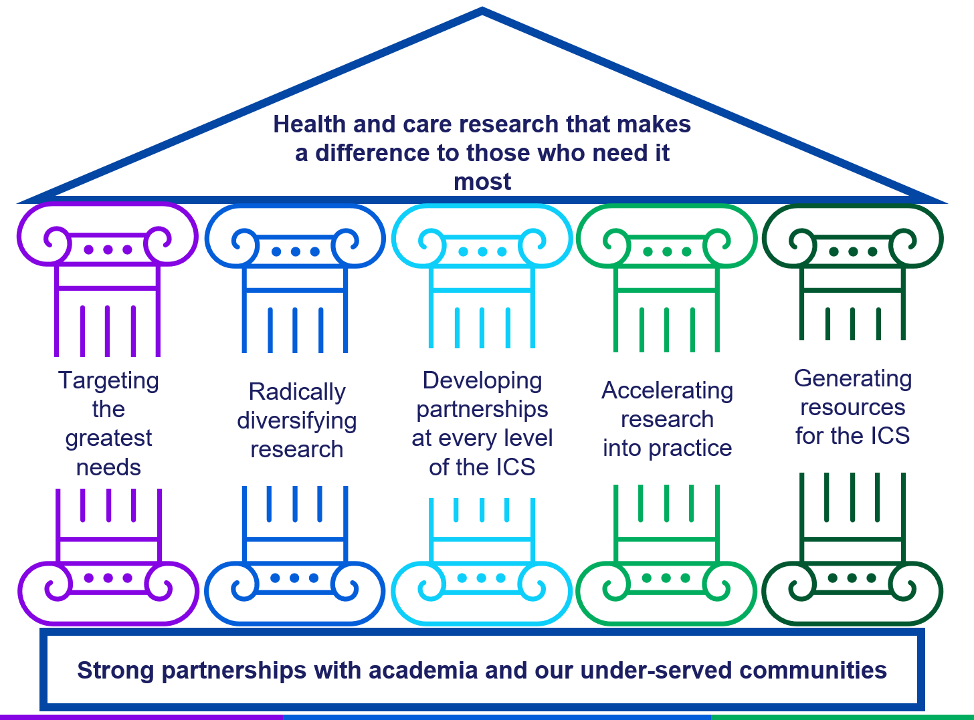
The diagram shows the title health and care research that makes a difference to those who need it most. The aims of the strategy. Targeting the greatest need, radically diversifying health and care research, developing partnerships at every level, accelerating research into practice and generating resources for the ICS.

The intent within the strategy is to develop research that is designed with diverse health and care colleagues, so that their tacit knowledge is made explicit and is embedded within the evidence produced. This will maximise the chances of implementation of the evidence to benefit our population.
Our research programme will increase our system’s skills, confidence and capacity to embed evidence.
The five Pillars will lead to an increase in BNSSG ICB securing external funding for innovation, which will be used to improve the health and wellbeing of our population with the greatest needs.
This strategy will harness research as a mechanism for reducing health inequalities and improving the health and care system for our patients and staff.

Acknowledgements

BNSSG ICB would like to thank all partners who have contributed to the development of this strategy. We work to support the great work of others, and your input has been integral throughout.
A special thank you to the community members at the Barton Hill Coffee Morning, who gave their time and their wealth of experience to help the author appreciate exactly why it is so important that we improve health and care research practice and the ability of research to improve services.
And to Caafi Health and Nilaari, the lead community organisations of our BNSSG Research Engagement Network. They are already delivering much of the future vision we aspire to help create and sustain, research focused on health inequalities being led and delivered by the communities who are in most need of the evidence.

Introduction
This document first sets out the rationale for why research is a fundamental element of an Integrated Care Board (ICB) and an Integrated Care System (ICS), highlighting enhanced opportunities for an ICB that is research-active.
The national policies that incentivise growth in academic research collaborations are then described, followed by a definition of the remit of the ICB’s research work within the context of the Healthier Together Integrated Care System and the Bristol Health Partners.
We present an overview of BNSSG ICB’s research activity to date and show that whilst we are performing very well compared to our peers, there are factors that limit our research from realising the potential benefits to our population.
This strategy was co-developed with many people with differing perspectives and needs regarding ICB research. We describe the process of exploring these various perspectives and needs and how our conversations revealed a shared aim and vision.
The vision is of a fully integrated research culture within the ICB, where collaboration, inclusion and innovation drive evidence-based improvements for our population and workforce.
The aim of our research programme is to ensure that health and care research makes a difference to those who need it most.
Our co-development process identified 5 Strategic pillars that will deliver the vision and aim of the ICB Research Strategy. The Pillars are purposefully designed to interact and enhance one-another. Therefore, a hypothetical example is used to demonstrate how the 5 Pillars will interact to deliver world-class research, that brings increased resource to our health and care system, for innovative projects that will address the greatest needs within our population, whilst enhancing the experience of our workforce and ultimately, reduce health inequalities.
The final section explains how we will monitor our progress and ensure this strategy makes a difference to those people in our population with the greatest needs.
The mission of BNSSG ICB is:
To make health better for all the people of Bristol North Somerset and South Gloucestershire.
The vision that drives this research strategy is:
A fully integrated research culture within the ICB where collaboration, inclusion and innovation drive evidence-based improvements for our population and workforce.
The aim of our research programme is:
Health and care research that makes a difference to those who need it most.

Background

Research within an integrated care board

Integrated Care Boards (ICBs) in England have legal duties regarding research, as outlined in the Health and Care Act 2022 [2]. These duties include:

- Facilitating Research: ICBs must facilitate research activities to enhance healthcare delivery and outcomes.
- Promoting Research: They are required to promote research efforts within their respective regions.
- Using Research Findings: ICBs must use research findings to inform decision-making processes regarding healthcare provision

These legal duties, if implemented well, will contribute directly to the BNSSG ICB aims, which are to:

- Improve outcomes in population health and healthcare
- Tackle inequalities in outcomes, experience and access
- Enhance productivity and value for money
- Support broader social and economic development

Nationally, health and care research is driven through the National Institute of Health and care Research (NIHR), which has a mission to improve the health and wealth of the nation through research. The ICB is in receipt of multiple funding awards from the NIHR and is contracted to deliver high quality research in collaboration with academic partners and works in partnership with our local Research Delivery Network.

There are further drivers for an ICB to engage meaningfully with research.

Research is one of the four pillars of clinical practice. The ICB has a leading role in supporting staff across our health and care system to engage in research activity, and to ensure staff are able to use evidence-based strategies to improve, inform and enhance the quality of care services.

The national context following the Darzi report (Darzi 2024), the NHS is developing a 10 year plan to deliver the 3 big shifts identified by the government:
- hospital to community
- analogue to digital
- sickness to prevention
These are complex challenges, the kind of complex challenge that research is well-suited to add valuable insight.

Research is a fundamental component of the work of an ICB, and not only is the ICB obligated to facilitate and promote research across the Integrated Care System, engaging actively and supporting research well can bring valuable insights into our most complex challenges, whilst bringing increased investment and skills into our health and care system.

The next section will highlight the direct benefits to health and care services that being research-active can bring.

How research participation improves outcomes

Beyond meeting their statutory duties, there are multiple benefits of an ICB being research active.

Evidence shows that research-active health and care organisations have better patient outcomes, even for those patients not participating in research (NHS England, 2023; Boaz et al 2015; Ozdemir et al, 2015). Delivering evidence informed care increases safety, efficiency and quality (Connor et al, 2023).

Patients and public are keen that their health and care organisations are research active (Hunn, 2017), and research is an empowering experience for service users who value inputting into the improvement of knowledge and care (Ocloo & Matthews, 2016).

There is also strong evidence that involvement in research improves job satisfaction, wellbeing and morale amongst health and care staff (NHS England, 2023; Ralph Rees et al, 2019).

Evidence shows that academic research has had little influence on the commissioning, design and delivery of health care services (Baxter et al, 2024; Wye et al, 2015) but that collaboration between colleagues working across health and care systems and academia can be an effective means of knowledge mobilisation (Greenhalgh & Wieringa, 2011). Knowledge mobilisation involves a two-way and ongoing process of moving knowledge between different expert groups, including patients, carers and the public.

Knowledge mobilisation provides a mechanism whereby research evidence can influence service delivery, and just as importantly, that knowledge from service delivery and health and care planning informs the design and the delivery of research. Without active involvement in knowledge mobilisation research will not be able to have a direct and meaningful impact on the health of our population and their experience of care.

Beyond the statutory and contractual obligations on the ICB to be research-active, there are clear benefits to our population and staff across the ICS, but research also brings the opportunity of increased resources being invested in NHS Organisations based on their research activity.

The virtuous circle

To incentivise collaborations between universities and NHS organisations, the Department of Health and Social Care (DHSC) award funding to NHS Organisations that host NIHR funded research projects. Incentivising collaborations drives alignment between academic interests and health and care priorities.

The incentivising funding is currently called Research Capability Funding (RCF). RCF is awarded based on the NHS organisation’s NIHR grant income in the preceding calendar year. RCF can be used to support research capacity, but also to invest in the development of new research projects which, if they are successful in securing NIHR funding, generates additional RCF in future years. This is the virtuous circle, a mechanism that rewards developing high quality research with funding that can be used to invest in further innovative projects that also bring the benefits of research to the population and staff alike.

The virtuous circle is the mechanism that BNSSG has used to grow our portfolio of NIHR grants from 2 grants in 2008 to 44 grants hosted in 2024 with combined a value of £49m.
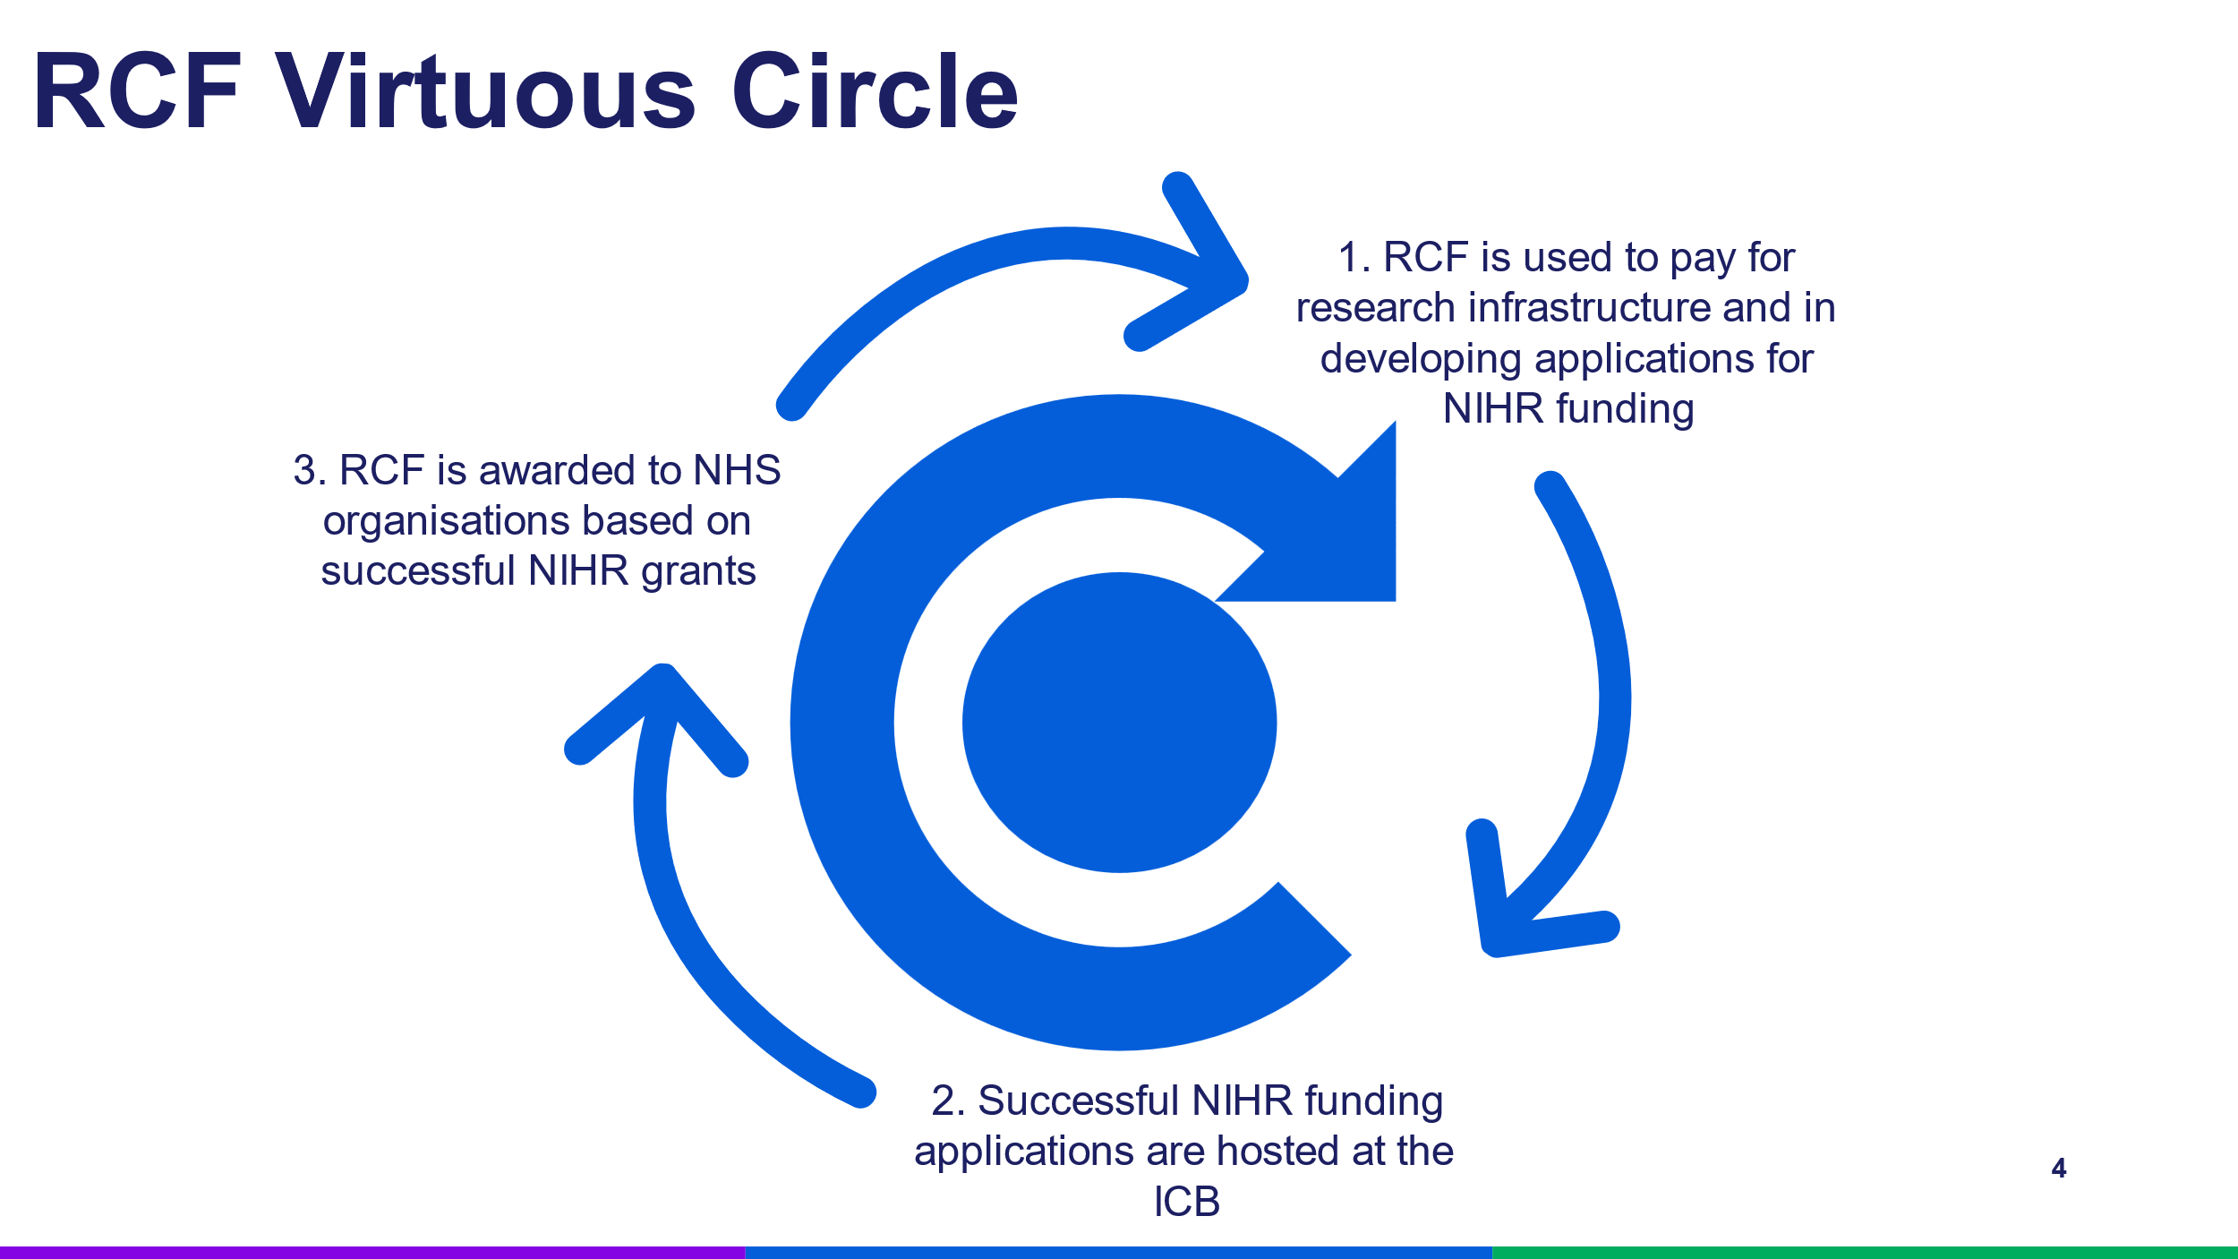

Image shows the RCF The Virtuous Circle showing three parts of the circle with arrows circling clockwise. 1. RCF is used to pay for research infrastructure and for time to support researchers preparing bids to NIHR schemes. 2. Grant applications submitted to NIHR funders and the successful grants are hosted at the NHS and monitored by APCRC. 3. In the following year, RCF is awarded to the NHS on the basis of the successful NIHR grants, and a ‘virtuous circle’ of funding is developed.

The ICB has invested RCF to increase our capacity to support research, to use evidence and to evaluate our services. RCF has also been invested in the development of research grant applications to the NIHR funding schemes.

Successful NIHR applications provide direct resources for high-quality improvement projects for our health and care system, but also generate further RCF in subsequent years.

Even the applications that were not successful have added value to the ICS through developing staff skills, providing the workforce benefits as detailed above and through creating mutually-beneficial collaborations between academia and health and care service colleagues.

The more RCF we receive, the greater the opportunities to invest in further evidence generation and use within our system. Continued growth of the ICB’s research portfolio and associated income generation is an important element considered within this research strategy.

The next section defines the scope and remit of the ICB’s research portfolio. This is not straight-forward within a complex health and care system encompassing many health and care providers.

The BNSSG ICB research team and what they do

The ICB Research Team remit and scope is to support health and care research within BNSSG, from the earliest idea development through to dissemination of findings and embedding evidence into practice.

The NHS Trusts within BNSSG each have internal research support teams that we work with to provide a comprehensive service for all health and care organisations within the Healthier Together ICS.

Our services and schemes are focused on supporting research within the ICB itself (for example Medicines Optimisation and/or Population Health Management) as well as our system partners supporting community health and care services. The image below presents the scope and remit of the ICB research team’s work, as well as the scope and remit of this research strategy.

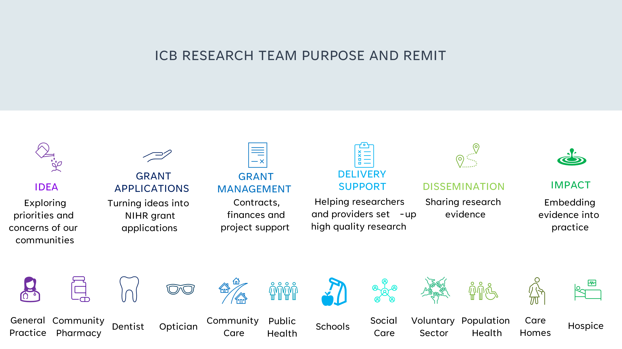
An infographic showing the ICB research team’s purpose and remit. They are responsible for idea-sharing, grant applications, grant management, delivery support, dissemination and impact. Research areas include general practice, community pharmacy, dentist, optician, community care, public health, schools, social care, voluntary sector, population health, care homes and hospices.

Having one team within our ICS to support all of these distinct areas of health and care reduces duplication of process, shares skills and knowledge to the benefit of all, creates an economy of scale to increase efficiency and pools resources into a strategically meaningful scale. This collaboration also opens opportunity of RCF to our system partners who are outside of the NHS, contributing increased benefits to all.

Our collaborative approach has made BNSSG an outstanding area for primary and community health and care research, providing us with a strong starting point for this strategy. The next section will provide more detail on the current state of research activity supported by BNSSG ICB.

Current research activity in BNSSG ICB

Since 2009, the ICB’s Research Team has worked in partnership with the South West Central NIHR Research Delivery Network (formerly West of England Clinical Research Network) and the Universities of Bristol and the West of England (UWE) to establish high levels of community-focused health and care research within BNSSG.

BNSSG ICB is consistently in the top two all NHS Organisations in England in terms of hosting awarded NIHR grants (1st 2022, 2nd 2023, 2nd 2024). Also, the general practices within BNSSG are consistently ranked as amongst the highest recruiters to primary care NIHR portfolio projects in the UK, contributing more than half of the recruitment from BNSSG, and providing 39% of the entire West of England region’s recruitment in 2023/24. Nationally primary care accounts for 20% of the NIHR recruitment activity, and comparatively, BNSSG performs very well.

These achievements are a testament to the successful partnership work between the ICB, academia, and the primary and community health and care services within BNSSG.

Our ICS is also fortunate to have two highly research active NHS Hospital Trusts, a research-active mental health Trust and two Universities with internationally leading health and care researchers.

The ICB collaborates with and aligns research programmes with ICS work with all the above mentioned partners through the Bristol Health Partners Academic Health Science Centre, ensuring that patients and under-served communities are at the heart of all of our research activity.

BNSSG ICB also benefits from working closely with our regional research infrastructure: the NIHR Research Delivery Network, Health Innovation Network West of England and the NIHR Applied Research Collaboration West of England, as well as the local NIHR infrastructure of the three NIHR Schools for primary care, public health and social care, the NIHR Bristol Biomedical Research Centre, NIHR Bristol Trials Centre and NIHR Health Protection Research Unit. All these elements combine to create a vibrant, supportive and collaborative research ecosystem within BNSSG that is delivering high levels of high-quality health and care research across BNSSG.

However, despite performing highly in comparison to other areas of England, we still have numerous areas for improvement when considering how our research is contributing to our system ambitions of:

- Improving outcomes in population health and healthcare
- Tackling inequalities in outcomes, experience and access
- Enhancing productivity and value for money
- Supporting broader social and economic development

The next sections set out the problems that our strategy needs to address as identified in our strategy development process. We then explain the strategy development process, before detailing our 2025-28 ICB Research Strategy that has been co-developed to enable us to harness the potential research offers for the benefit of the ICS and our population.

The problem this strategy aims to address

For a strategy to be effective, it is essential that clearly defined problems are identified and that the strategy considers available resources and opportunities to address these. From the co-development process with stakeholders, several issues have been identified that are limiting the effectiveness of our research activities to contribute to the Healthier Together aims and priorities.

These issues can be described as our knowledge mobilisation problems:
- Inclusion within research: Research often excludes people who have the greatest needs. Therefore, implementation of the evidence generated through that research cannot deliver equitable services. Examples include racial disparities in oxygen supplementation within intensive care units due to the lack of diverse populations in studies on pulse oximetry (Gottlieb 2022) and the recent finding that Clopidogrel, used to treat people after a heart attack, is ineffective for British people of Bangladeshi and Pakistani ancestry (Magavern 2023), further exacerbating the impact amongst under-served populations with high prevalence of heart conditions. Low inclusion means that there is under-representation of all protected characteristics within the participants of health and care research. Locally our diverse Research Engagement Network (REN) focuses on racially minoritised communities, and our GP Deep End network focuses on the most economically disadvantaged areas.
- Mismatch Between Current Research and ICB Challenges: Across the entire NIHR portfolio there is often a disconnect between the research being conducted and the pressing issues that Integrated Care Systems are addressing. The mismatches can be on the population in focus; the research methodologies used and data required; as well as the topics being investigated.
- Under-representation of System Workforce in Research: The system workforce is not adequately represented in the generation, delivery and implementation of research. All population outcomes depend on staff involvement, yet not all staff groups are engaged in research. Addressing this gap is crucial as research can serve as both a solution finder and active engagement with research is a mechanism for service improvement in-of-itself.
- Scarcity of R&D Resources in Health and Social Care: There is a notable discrepancy of research and development resources within community health and social care settings, primary care accounts for 20% of the NIHR portfolio recruitment but receives just 6% of the budget, and community and social care receives an even smaller proportion. This scarcity hinders the ability to conduct necessary research that can inform and improve service delivery in these critical areas.
By addressing these problems, this strategy aims to enhance the mobilisation of knowledge, ensuring that research is inclusive, aligned with real-world challenges, representative of the workforce, and adequately resourced.

Knowledge mobilisation has been a key element of previous research strategies within preceding health commissioning organisations (CCGs, PCTs) and is an underlying principle of how the ICB’s Research Team operates. We recognise that our focus on knowledge mobilisation is a key element in why BNSSG ICB research activity is outstanding compared to our peers. This strategy will build on and widen the participation across our ICS, with the expectation that this will increase the volume of research in BNSSG and enhance the impact the research will have on those in our population with the greatest needs and largest health inequalities.

We have implemented a knowledge mobilisation approach to developing this strategy. The next section will explain our strategy development process before we set out the ICB research strategy in full.

How we developed this strategy

A knowledge mobilisation approach has been critical to the success of BNSSG ICB’s research programme to date and has been used to co-develop this research strategy.

The development of this strategy started with a Strengths, Weaknesses, Opportunities and Threats (SWOT) workshop for the ICB Research Team. All contributions from the workshop were collated and grouped into 4 emergent themes. The four themes were that our research should:

- Address health inequalities
- Maximise research resources within the ICS
- Create and utilise impactful research and evidence
- Deliver a Joint Office for all community and system-level health and care research in BNSSG

These themes were used as the basis for discussion with numerous stakeholders, including colleagues from various teams within the ICB, multiple groups within our local academic institutes, all three of our Local Authority system partners, health and care provider organisations, and voluntary and community sector organisations working with under-represented and under-served communities in BNSSG.

We have also discussed the developing strategy directly with patient and public contributors from communities who are under-represented in health and care research. Whilst the contributors welcomed the opportunity to be part of the development of the ICB’s research strategy, they also voiced strong suspicions of our motivation for inviting their input that should be acknowledged here as trust in health and research is a key factor driving this strategy.

The contributors emphasised the importance of demonstrating through our actions that their input was not a tick-box exercise to assert that we have fulfilled our obligations by inviting their input, or a cynical gesture to appease under-represented communities.

Therefore, we commit to proactively seeking regular opportunities to be held to account for delivering this strategy by working with communities and organisations who are typically under-represented in health and care research.

We acknowledge that we have not included the views of all communities and relevant perspectives in the development of this research strategy. We are grateful for the openness and passion of the public contributors who are helping us to understand and better achieve our shared ambition, that ICB research contributes to reducing health inequalities amongst those who have the greatest needs.

All feedback and input from the stakeholders has been considered using an Objectives and Key Results methodology to define the problem and to design the strategy that will address the identified problems.

The next sections define the vision, aim and 5 Pillars of the 2025-28 ICB BNSSG Research Strategy that we believe will both increase research activity across the ICB and the benefits to our population from our research portfolio.



Research Strategy
2025 to 2028

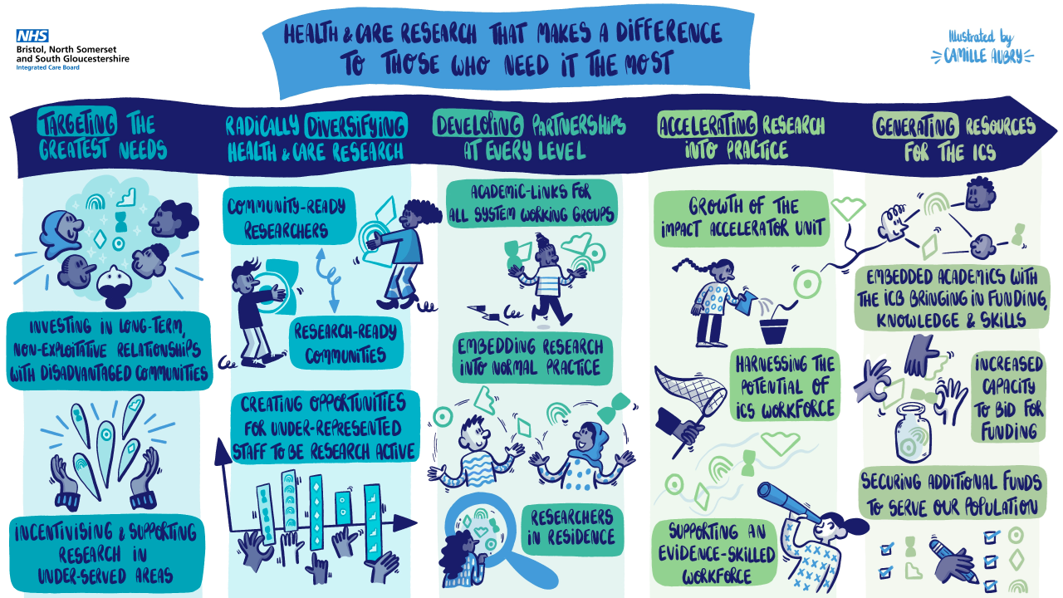

Vision: A fully integrated research culture within the ICB where collaboration, inclusion and innovation drive evidence-based improvements for our population and workforce.

To address our gaps in knowledge mobilisation, namely low inclusion of people with protected characteristics within research, the mismatch between current research and ICB challenges, under-representation of workforce in research and the scarcity of R&D resources in Health and Social Care, we propose a dramatic disruption to how we have considered research within the ICB.

Until now, research has been an activity that exists alongside system work. Research has not been embedded within core business of the ICB and is often seen as “a nice to have add on”.

The underlying principle for this strategy is that we hardwire research into core business and become an ICB that enhances all of its activities through research collaborations and participation. We aspire to have close collaboration with academia at all levels and aspects of our day-to-day activity as a defining feature of how our ICS operates with staff across the ICS understanding that research is a normal feature of working in the Healthier Together Integrated Care System.

Actively embedding researchers into system work will immediately increase the skills and knowledge available to bring to bear on system work, as well as providing our academic projects with the credibility and trust that the health services and system partners have with our under-served, under-represented communities.

Embedding research into usual business will accelerate and enhance the alignment of our research portfolio with the challenges our system is actively addressing, with deeper understanding of the issues, and the methods for addressing these issues. Working together in shared spaces will lead to a shared language between colleagues, a greater capacity for delivering evidence informed practice and enhancing our ability to secure external funding to drive service improvements.

Embedding collaboration with academia into everyday working exposes wider members of staff across Healthier Together to opportunities to participate in research activity. Due to entrenched barriers for staff who are under-represented in research, by way of cultural heritage, protected characteristics or profession, active investment and support will be required to ensure these opportunities are viable and available to those who have been least engaged and have the greatest structural barriers to overcome.

Embedding research into the standard expectations of staff and services across the ICS will require culture to shift, and the ICB is well-placed to create structures that encourage this shift. This will include understanding and removing barriers for staff to be research-active as well as a greater emphasis on communicating research activity, opportunities and findings. BNSSG is by far the most research-active ICS in England in terms of NIHR portfolio and the ICS would reap benefits from celebrating this strength and encouraging our workforce to be an active part of the future research activity.

With research being more visible, accessible and considered as a normal part of ICS staff roles, research can be utilised as a mechanism to support multiple programmes of improvement across our ICS, including the People and Culture Plan to create a learning culture across the ICS, the development and learning from innovations within Healthier Together 2040, the community embedded development work of our Locality Partnerships, as well as Innovate Healthier Together and the Transformation Gateway process led by the Transformation Directorate within the ICB.

Academic colleagues gaining direct experience of health and care planning and commissioning will enrich the planning of research and teaching. This will create research that is more aligned to needs, evidence that is more readily applicable to influencing policy and service delivery and teaching that provides a deeper understanding that will better prepare the next generation of health and care planners to deliver evidence informed commissioning.

Embedding research into normal ICB functions and across all of our activities will enable our scarce R&D resources in Health and Social Care to be focused on tasks where specialist knowledge and resource is required. Currently our Research Team is the rate limiting step, a bottle neck, for collaborations and project development with limited capacity to deliver bespoke project-by-project support. Empowering existing system groups to truly own research as a component of their work will dramatically increase the capacity our system has to develop and deliver research. All of which will bring external funding into our system that will benefit our patients and population and generate more RCF that will contribute to our strategic investments and ability to support world-class research that makes a difference to those who need it most.

The Research Team will build structures and processes to support teams across Healthier Together, so each team is able to harness research as a mechanism for staff development and satisfaction, as well as income-generating service improvements that will contribute to the ICS priority of supporting broader social and economic development within BNSSG.

The Background section sets out the justification for the ICB to adopt this vision of a fully integrated research culture within the ICB where collaboration, inclusion and innovation drive evidence-based improvements for our population and workforce, the next sections explain the Aim of our research strategy and how we propose to realise the benefits of the opportunities we have.

Aim: Health and care research making a difference for those who need it most

Being research active brings many benefits to an organisation, to their staff, to outcomes and to service users alike. However, to fully realise the opportunity that research offers we need to utilise the increased funding, the additional skills and resources to focus on the most enduring and difficult challenges our ICB is tackling.

The overarching aim of our ICB’s research programme is to ensure that research makes a difference for those who need it most. This means our research is:
- Focused on issues that matter to communities and where research can improve outcomes.
- Co-designed with those people most under-served by current health care provision and suffering the greatest inequalities in access, experience and outcomes of health and care services.
- Open and welcoming to all staff across our system who are offered supportive opportunities to be involved in research design, delivery, dissemination and implementation.
- Designed to provide meaningful evidence, that has been designed so that it can be utilised in commissioning decisions and service improvements.
- Being actively used, with a proactive pursuit of implementation by skilled and empowered staff across our ICS.
- Used systematically to ensure that the communities who most need the evidence hear about the research, are involved in the dissemination of research, and are empowered to help our system learn from and implement the findings of the research.

To achieve the aim of creating research makes a difference for those who need it most, the mission of the research programme will be to:

- Be the best ICS we can be at delivering knowledge mobilisation
- Optimise research generation and evidence use throughout the ICS
- Increase the resources available within the ICS to address health inequalities through research funding and academic expertise
To deliver this mission, our co-development has identified five strategic pillars that will be led by the ICB’s Research Team:

- Targeting the greatest needs
- Radically diversifying health and care research
- Developing Partnerships at every level of the ICS
- Accelerating research into practice
- Generating resources for the ICS
The next section will focus on each of these five Pillars and then describe how they will positively interact to deliver the Aim of creating health and care research that makes a difference for those who need it most. The five Pillars will be used by the ICB Research Team to devise their three-year and annual operational delivery workplans.

This document ends by setting out how progress to this strategy will be monitored within the ICB to ensure we deliver programmes of work that are needed to meet our aim of health and care research that makes a difference to those who need it most.

Targeting the greatest needs
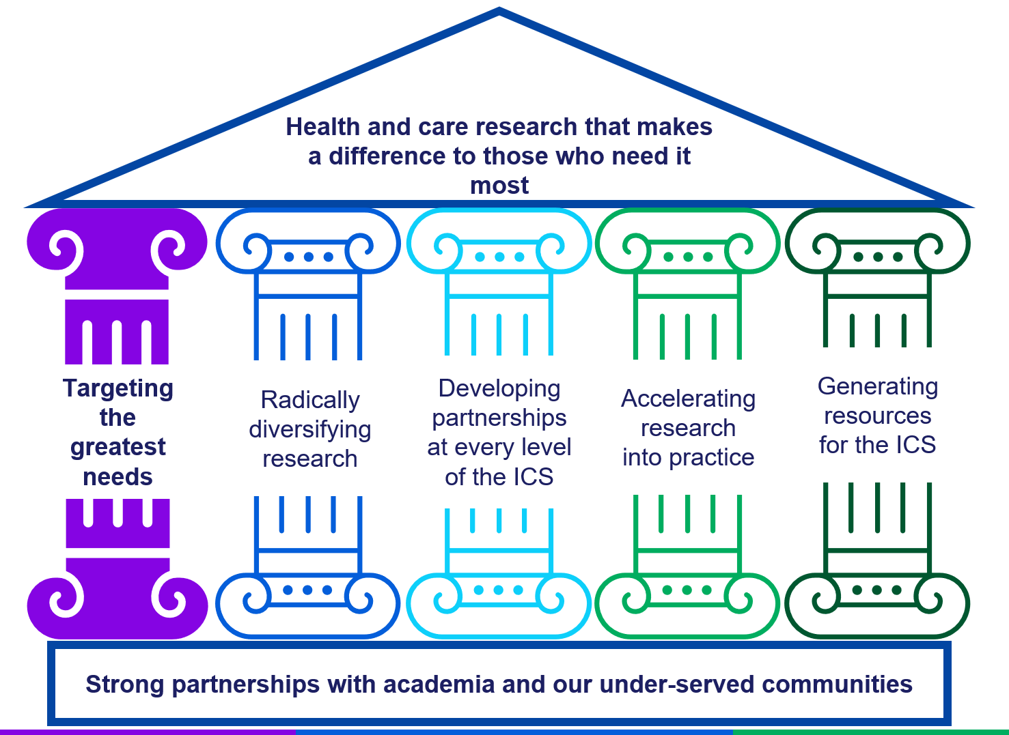
To maximise the benefits of research for our population, we need research to be focused on the enduring and complex challenges of health inequalities.

Research needs to proactively work with our CORE20PLUS populations. These are the 20% of people living in the most deprived areas of BNSSG, our ethnically minoritised communities, people with a learning disability and/or autistic people, and the members of our population with multiple long-term conditions.

We need research to be co-developed with those people who have the most need of the insights and improvements that the research could offer. That is the only way to ensure that the project is inclusive to their needs and will be able to recruit and retain participants throughout.

We need research active staff to be skilled and supported to work in trauma-informed and anti-racist ways, with high competency in cultural humility and a strong understanding of health inequalities. We are calling researchers with these skills “community ready researchers”. To deliver our aim of health and care research that makes a difference to those who need it most, the ICB needs to help all our research projects reach community ready standards.

We need the health and care staff across all ICS partners working with the communities with the greatest needs to be involved in the design, the delivery and the dissemination of research. The ICB will need to create an environment and systems that incentivise and support research activities within these health and care organisations that are operating under highly challenging circumstances.

How will we achieve this?

The ICB will create and sustain mechanisms to:

- Build and maintain long-term relationships between under-represented and under-served communities and research groups.
- Ensure researchers are ‘community ready researchers’ so they are enabled to deliver all ICB related research at a high standard of inclusive research practice.
- standardise ways of working so that our research is non-exploitative and actively empowers communities through participation.
- Seek and develop community derived research projects on issues that are their priorities.
- Incentivise research development within the health and care services that serve our CORE20 populations.
- incentivise research development that actively supports our Healthier Together priorities and addresses issues raised in our system working groups (e.g. Operational Delivery Groups).
- Support community delivered research projects, where VCSE staff benefit from training and mentorship from trained community ready researchers and are the direct beneficiaries of research grant funding.

Ensuring that our existing networks, the Research Engagement Network (REN) and the GPs at the Deep End network, flourish and grow will support researchers in BNSSG to have access to our CORE20 populations, and the health and care services providing their care. Those CORE20 populations will benefit from participation in health and care research delivered in community ready way, as well as the ICB’s incentivising of research activity in the VCSE and general practices serving delivering the services that they are offered. The ICB’s incentivisation of research will lead to direct service improvements within the organisations supporting our population with the greatest needs.

Members of our communities will benefit from coordinated activity, allowing their ideas to develop into improvement projects, ensuring their voices are heard throughout the design, delivery and dissemination of high-quality research. Further, this activity will bring direct investments into community providers, skills development within communities and increased health education.

By targeting those with the greatest need, our health and care research resources will directly and indirectly bring improvements to our CORE20 population.

Radically diversifying health and care research
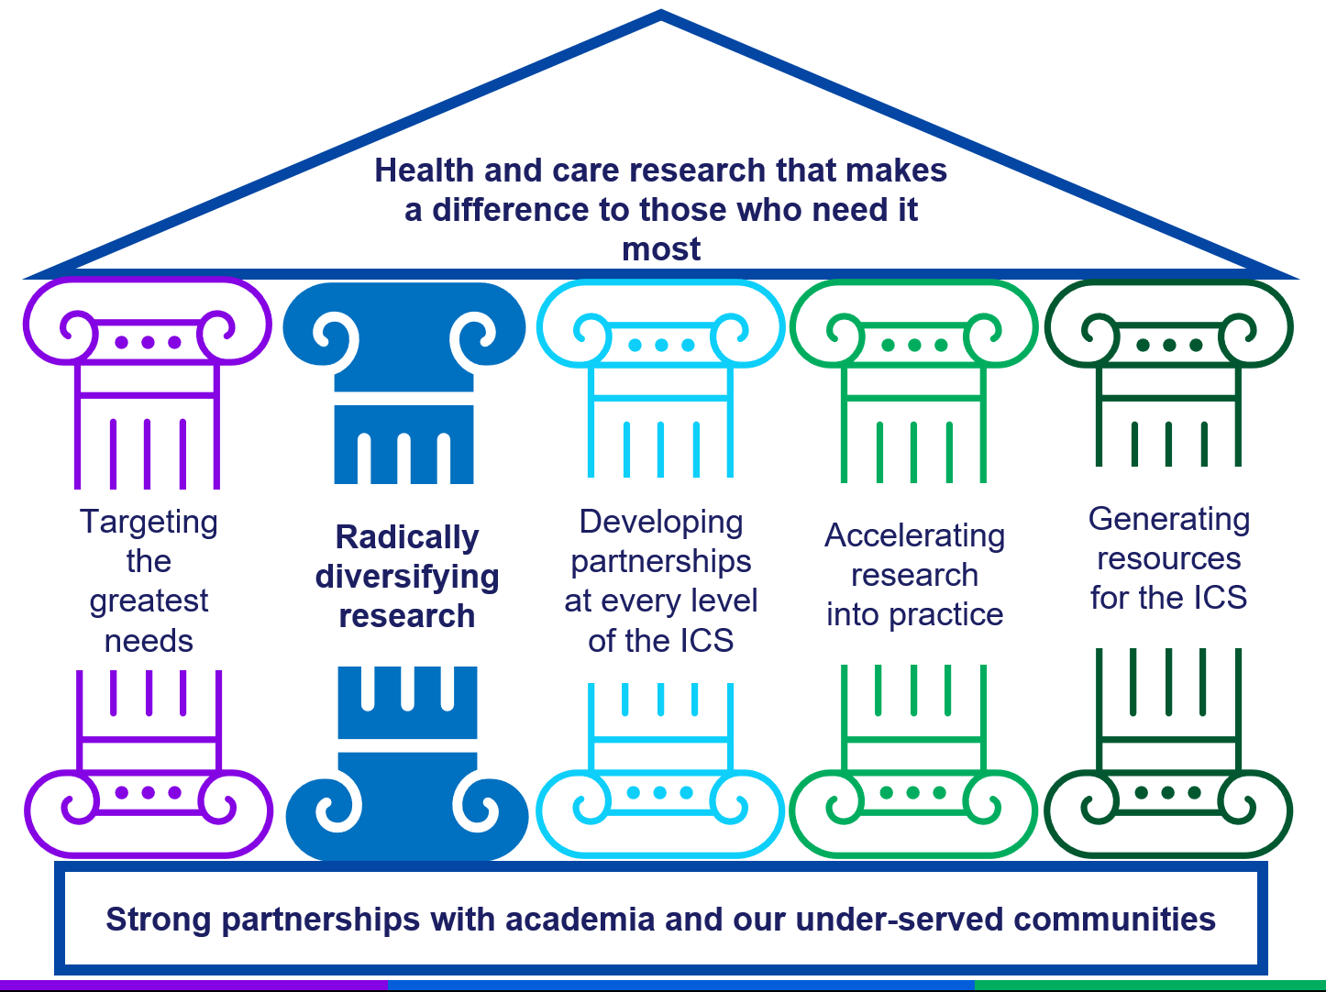
Communities who suffer the worst health inequalities are under-represented at every stage of research development and delivery. The health and care service staff who support those communities are also under-represented in our research workforce. Nurses, Allied Health Professionals, Social Workers and VCSE Sector staff have by far the greatest proportion of interactions with the members of our community with the greatest needs, and yet these staff are only rarely given opportunities to lead on and actively contribute to health and care research.

This under-representation impacts all stages of research development, delivery, reporting of findings and implementation of evidence into practice. This under-representation directly contributes to widening existing health inequalities, as the evidence that is used to improve access, experience and outcomes comes from only those people and staff who have been included in the research process.

As a leading research-active ICB with strong partnerships with academic institutions and system partners, BNSSG ICB is well-placed to radically alter the current status-quo.

How will we achieve this?

This will involve:

- Establishing long-term trusting and non-exploitative relationships with communities who are under-served by health and care services and traditionally under-represented in health and care research.
- Proactively supporting research to include community-researchers in co-production and research delivery.
- Training and supporting all associated researchers to become “community ready researchers”.
- Coordinating and investing in Research Ready Communities, with an ambition of accredited training opportunities that increases our community research capacity through investing in skill development in our VCSE partners.
- Adequate longer-term stable levels of investment in infrastructure to support community engagement, including translations and equitable payment mechanisms to participants and PPI contributors.
- Investing in the skills and knowledge of staff within community partners who could support research, so that they are enabled to design and deliver their own research and evaluations as well as contribute and collaborate on NIHR portfolio research.
- Aligning activities across the ICS, so that we do not keep asking the same communities the same questions but utilise the data our system partners have already gathered and take actions and demonstrate these actions back to the communities who contributed the data and insights and who could benefit most from the actions.
- Proactively supporting under-represented staff to develop and thrive in research-active careers. By under-represented staff we mean the under-representation of ethnically minoritised staff, staff with other protected characteristics and also the under-representation of professional groups within research, such as Nurses, Midwives and Allied Health Professionals (NMAHPs) and staff within the VCSE sector. By proactively supporting we mean dedicated training opportunities, targeted funding for career development, creating mentorship schemes and partnerships between research teams and system colleagues, and removing systemic barriers to research participation amongst under-represented staff.

We believe these actions will lead to inclusive research thriving in areas of BNSSG that have not benefited from research previously, with research-career opportunities becoming available to a wider range of professionals across the ICS, including NMAHPs, Social Care Workers and colleagues within VCSE. These will lead to greater capacity to deliver community-based research; an increase in research development from under-represented communities and the health and care services supporting our population with the greatest needs; more awareness of and confidence with research evidence across our ICS, increasing our capacity for implementation of evidence; and more impactful research findings that actively reduce health inequalities when implemented.

Developing partnerships at every level of the ICS
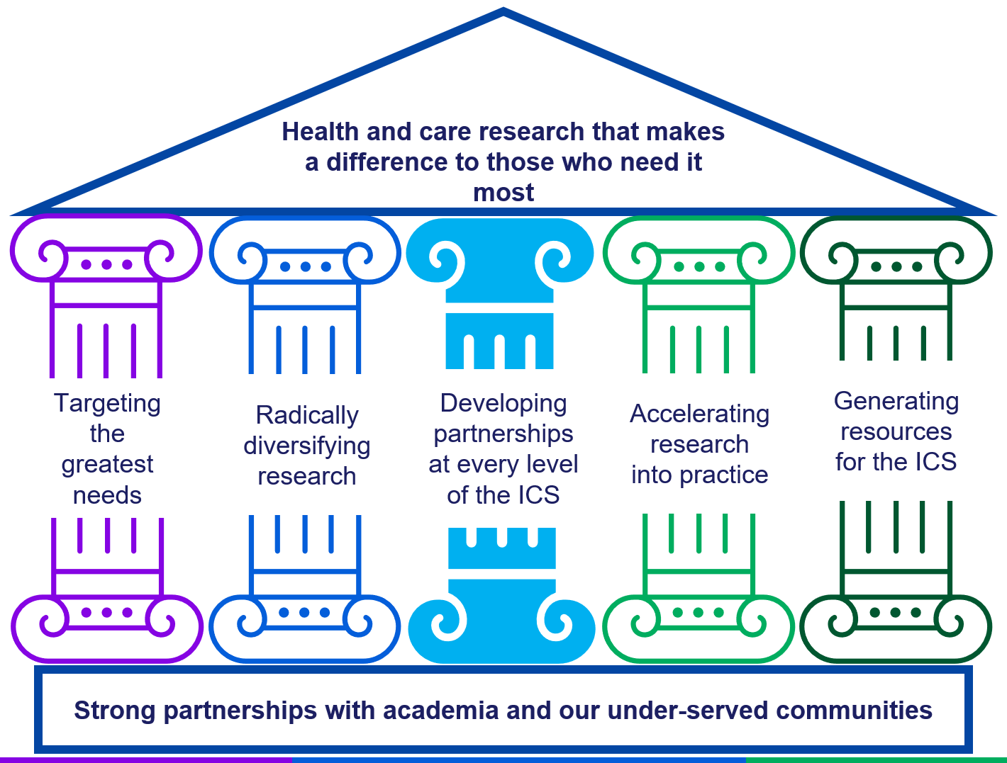
The ICB is mandated to implement research evidence into practice. However, due to our knowledge mobilisation problems of low inclusion within research, a mismatch between current research and ICB challenges, under-representation of system workforce in research and a scarcity of R&D resources in health and social care, we often struggle to find existing evidence that directly addresses our immediate needs.

For evidence to be implementable, it needs to have been designed with the system workforce who understand not only the condition of interest, but the context within which the system is operating. The research needs to be focused on real-world issues and provide solutions that are workable within the constraints and the context they will be applied within. Paradoxically, the onus of achieving fully-informed research has up till now been the responsibility of researchers who work outside of the health and care systems that have the detailed understanding of the needs, constraints and context.

This strategy sets out our ambition and identifies mechanisms to overcome the barriers of parallel working, where academia and system delivery are two separate activities. Unless we change those ways of working, we will only rarely generate or find research evidence that is applicable within the ICB to improve the lives of our population. To deliver evidence that will impact real-world decision-making, it is essential that the research is developed with the health and care planners and commissioners active in the design, as well as the health and care providers and the patients. It is also essential that use of evidence skills and knowledge are core to the ICS decision making processes. Maximising the benefits of research requires truly integrated collaborative working across our ICS and academic partners. We aspire to make evidence informed health and care planning and commissioning decisions the norm, rather than the exception. We know that personal relationships are key to knowledge mobilisation, both at the research design stage and for implementation of evidence to make a difference to health and care practice and outcomes.

To realise our vision of collaboration with academia being a defining feature of how our ICS operates, with an informed and engaged workforce, we need spaces where collaboration with academia is easy to achieve and becomes common practice. We believe there are tangible benefits that can be realised through academic collaboration at all levels of the ICS.

How will we achieve this?

We will deliver a programme of research partnerships that builds on examples from the MSK Programme, Population Health Management and Modelling and Analytics within the ICB, as well as programmes of work within Medicines Optimisation, where integration with academia has brought tangible benefits to the work of the ICB, whilst simultaneously helping academics to secure research income, publish papers and demonstrate real-world impacts.

Further mutual benefits from these collaborations include academic colleagues gaining networks of health and care professionals, extensive knowledge of the health and care system and the practicalities of designing and delivering impactful research within complex systems, as well as having mechanisms for realising impacts from their research evidence.

ICB colleagues gain networks of subject matter experts, additional evidence and evaluation skills and expertise that can be drawn on for ICB projects, including evidence review and evaluation planning as well as access to additional resources through external funding.

These collaborations often lead to ICS improvement projects being delivered using external funding, that brings additional highly skilled staff and innovative interventions at no cost to the ICB.

We will embed colleagues from our Partner Universities within ICS delivery groups, including our Health and Care Improvement Groups, Operational Delivery Groups, Healthier Together 2040 and Locality Partnership Boards. We will embed researchers into the ICB’s transformation process, to support insights and evidence, to support planning and evaluation of changes, and to secure external funding to deliver innovative practice.

We will ensure that at least one member of an ICS delivery group with embedded researcher is integrated within University-based communities of practice, including Bristol Health Partners Health Integration Teams (HITs). This will create multiple opportunities for collaborations to develop.

These collaborations will actively support our ICS culture of learning, with immediate benefits of bringing increased evidence skills within the ICS, and growing skill development and income for the ICS, whilst producing evidence that supports us to improve the health of our population.

Research development ideas from these collaborations will be prioritised by our Research Capability Funding schemes, providing a short-term funding incentive to both University and ICB colleagues to engage with this strategic pillar and align our research portfolio with system needs.

This strategic pillar will help with the knowledge mobilisation problem of scarce resources for R&D by helping to hard-wire research into core-business across the ICS, and creating multiple routes to increase the alignment of our research with our system priorities, rather than continuing to rely on a small Research Team to be a main conduit of knowledge mobilisation between the ICs and our academic partners. This pillar will increase the quality of our evaluations and evidence skills within the ICS, and bring increased resource into our system through applications for external funding to deliver enhanced system projects. It will also create the spaces required for accelerating evidence into practice.

Accelerating research into practice
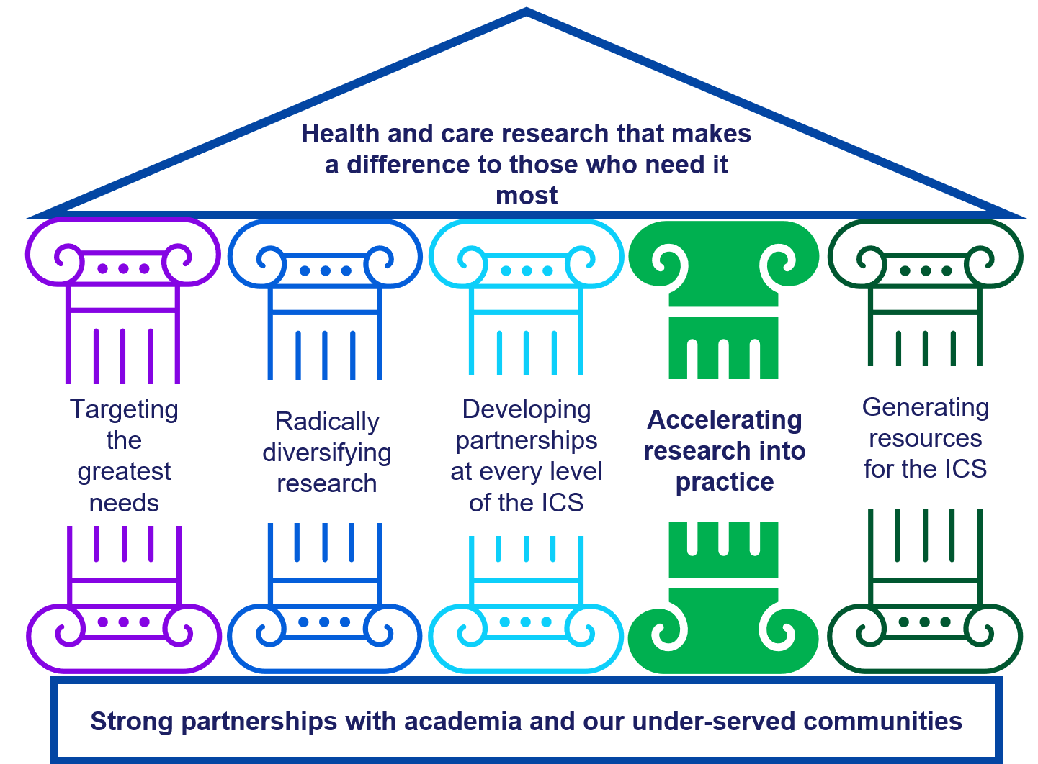

ICBs are mandated to use research findings to inform decision-making processes regarding healthcare provision. However, the best evidence suggests it takes around 17 years from evidence being published to it being routinely embedded into health and care practice.

Even if the research has been co-designed to ensure the evidence targets the greatest needs and incorporates practice and system knowledge to make implementation viable, it is still a challenge to actually embed evidence.

There are multiple reasons that contribute to this, and we recognise a major obstacle is that is a gap in dedicated funding and expertise.

Research staff are contracted to deliver a research project, and the contract ends often before the paper is published. This is the point at which evidence is ready for implementation. Further, implementation is a different skill from delivering research projects and requires different knowledge. Therefore, expecting academics to deliver the implementation of evidence into practice is not a realistic expectation.

Likewise, Health and Care staff are contracted to deliver services, and there is more demand than can be met across all services. Further, implementation of evidence is a different skill from delivering services and requires different knowledge. Therefore, expecting health and care service staff to deliver the implementation of evidence into practice is an equally unrealistic expectation.

Traditionally there has not been dedicated funding or a service to provide structured processes and support to individuals delivering implementation of evidence.

How will we achieve this?

The ICB has an innovative Impact Accelerator Unit (IAU), a partnership with the Universities of Bristol and UWE focused on embedding the latest evidence into our system to benefit our population.

During the term of this strategy, the Impact Accelerator Unit will establish itself locally and expand its regional and national networks and influence.

The IAU provides coordination of activities, training support, mentoring from knowledge mobilisation specialists and ring-fenced funding so that academics and health and care system staff can work together, access training and undertake the activities to embed evidence into practice.

The regional and national networks will increase the impact of our home-grown research by spread to other areas, and create an opportunity for our population to benefit from research evidence that has been produced and embedded successfully elsewhere in the country.

The IAU will create opportunities for staff across the ICS who are seeking ways develop and to demonstrate how they are delivering on their research pillar. The IAU within the ICB is well placed to coordinate and harness the opportunity that this offers.
Contributing to strategic developments in the ICS’ People and Culture Plan, as well as practical support to individuals and service delivery teams, the IAU will create mechanisms that support embedding evidence that benefits patients, services and the staff delivering the evidence informed practice.
Matching staff who are in need of a project with evidence that has recently been produced and is in need of someone who can undertake the practical steps to embed that evidence would help our system rapidly embed evidence into practice and contribute to our learning culture.
The IAU will support an evidence-informed workforce to grow across our ICS, whilst creating opportunities for staff traditionally under-represented in research to deliver on their research pillar in ways that actively contribute to our system goals of reducing health inequalities.
The IAU has secured funding from both local Universities and is gaining contributions from individual research grants. The aim of the IAU is to become largely self-sustaining, reducing the need for funding contributions from our University Partners and becoming a resource-generating scheme for the ICS, bringing increased external funding and increased skills to our system, all with the focus on reducing health inequalities.

Generating resources for the ICS

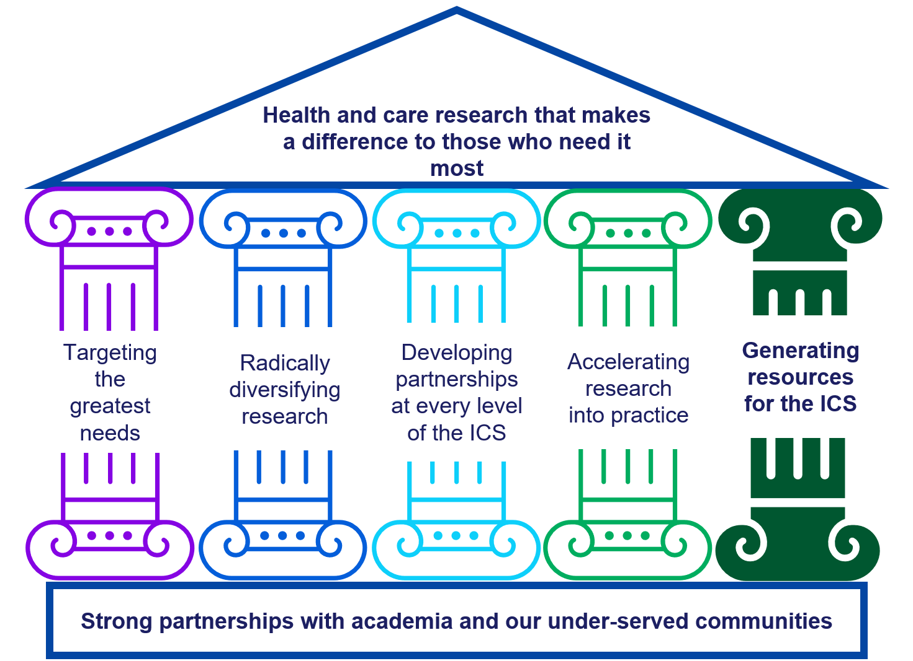
To achieve all of the above we will need increased resources within our system. By resources we mean funding, people, knowledge and skills.
There is a large amount of health and care research funding in the UK, funding that can enable us to increase the number of people and the variety of skills working on ICS challenges. Compared to our peers BNSSG has a fantastic record in securing research funds in collaboration with our academic partners.
However, we can do significantly more to see benefits from our current level of income, through greater alignment of inclusive community-based research with our system challenges, but there is also real potential to significantly grow our income levels as well.
The government priority is to shift care from Hospital to Community, from Analogue to Digital and from Sickness to Prevention. Each of these requires a focused research evidence base and multiple health and care research funders are looking to invest in these priorities in support of the government aims.
This strategy looks at how we can harness this golden opportunity to drive improvements for our population, whilst increasing our capacity to evaluate and to evidence our improvements through increasing the research income to our system. Our strategic pillars will ensure that as our resources grow the benefits are realised across our ICS, focused on our greatest needs and felt by our communities who need this evidence most.
Realising the potential of this strategy relies on staff across the ICS considering research as a realistic and viable mechanism for delivering innovation to address the challenges they are tackling.
How will we achieve this?
With the increased connectivity between health and care planners and academia through Pillar 3 above, more ICS working groups will be able to consider research as a viable mechanism of delivering improvements.
Two rate-limiting factors that currently exist are:
- the capacity of the ICB Research Team to connect system colleagues with researchers, and to foster their relationship on a project-by-project basis, and
- the availability of skilled staff to lead collaborative applications for external funding. Those with the skills are almost always fully committed to existing projects.

With our university Partners, we will invest in innovative roles that straddle academia and the ICS. These will be resource-generating roles who will be perfectly placed to lead on applications for external research funding.
Based on the model of existing joint academic-ICB roles in Knowledge Mobilisation, Data Analytics and Health Economics, these resource-generating roles will be embedded into our system working groups of strategic importance and charged with leading applications to secure external funding. The external funding will bring more people and enhanced skills to bear on the most complex challenges of the ICS.
Target areas will include prevention, health inequalities, care closer to home and managing multiple long-term conditions.
The post-holders will have the training and experience to lead grant applications for research funding, and from being embedded within the system working groups discussing the real-world issues, they will have a greater understanding of the challenge being addressed, and an immediate network of experts to draw upon with the deepest understanding of the context and constraints of service delivery.
These roles will bring benefits to the university through increased income and research impact; to the ICS by enabling innovation and evaluation through deploying enhanced skills, increased person-power and opportunities that increase job satisfaction across our workforce; and to our population through deeper understanding of their challenges, more co-developed solutions, and innovative practice being paid for through external budgets so that there is more funding available for innovation and routine services alike. These roles will resource-generating roles will lead directly to more effective services, greater opportunities to participate in research development and delivery, and our ability to demonstrate those impacts.
A by-product of the roles will be more real-world experience of health and care commissioning embedded into teaching and training of the next generation of our health and care workforce.
Utilising the ICB Research Team to establish relationship at a Programme level, rather than project-by-project, will dramatically increase the capacity of our system to apply for external funding for innovation and evaluation. This will lead to increased collaborative grant applications being submitted to external funders. The full cost of these improvement projects will be covered by the external funding and any NIHR income will generate further income to the ICB through the Research Capability Funding (RCF) award from the DH&SC.
RCF will be invested in the development of more system-aligned research projects, and further drive our virtuous circle, increasing our ability to create health and care research that makes a difference to those who need it most.

Pillars in practice

The strategic pillars are intentionally overlapping and interactive, with the expectation that these interactions will generate further emergent benefits that will contribute towards our aim of creating and supporting health and care research that makes a difference to those who need it most.

The ICB Research Strategy will enable us to:

- better understand health inequalities,
- establish broader and deeper collaborations with academic colleagues,
- create service improvements whilst generating income,
- enhance the skills across our workforce and the working experience for staff,
- improve the experience and outcomes for our population.

This strategy will increase the ICB’s capacity to develop new research across our system, leading to growth in our research portfolio. Growth in the research portfolio means increasing the opportunities to invest in new research and capacity through the virtuous circle of research investment.

Growth in the research portfolio also increases the opportunities for staff to develop and participate in research, and actively contributes to the ICS’ People and Culture plan to:
- Create a supportive and inclusive learning culture that enables our people to thrive and deliver exceptional care to the communities we serve.
- Foster a culture of collaboration, diversity, respect and life-long learning where every individual feels valued and empowered to achieve their personal ambitions.
- Recognise talent, facilitate the sharing of expertise and develop pathways into and within our workforce.

This strategy will enable our research activity to be one of the mechanisms to drive the People and Culture Plan.

The Government drive to shift health and care from Hospital to Community, from Analogue to Digital, and from Sickness to Prevention creates the ideal opportunity for this Research Strategy to deliver meaningful benefits to our population with the greatest needs.

Monitoring

We recognise that we work within a complex system and approach this strategy with the understanding that the response will be unpredictable and requires monitoring and adjustments.
Work Plans
The ICB’s Research Team will create a three-year work plan, as well as an annual work plan to deliver on the strategy, with key performance indicators to monitor progress.
The Research Team will adopt a Plan Do Study Act (PDSA) approach to monitoring the performance and expected changes this strategy is intended to bring about.
The three year and annual work plan will be reviewed by the Research and Knowledge Mobilisation Advisory Group, a group that will have membership from key partners including both Universities, all three Local Authorities, primary care and community care providers, VCSE representation and Patient and Public contributors.
Oversight
Day-to-day management and monitoring of operations will be the responsibility of the ICB’s Research Team Meeting and Impact Accelerator Unit Management Meeting.
A Lead will be appointed to each of the strategic Pillars, and we will establish a regular group for the staff leading the delivery of the ICB Research strategy, bringing together various roles that embody the integration of academia and the ICS.
All research activity will be reported to the Research and Knowledge Mobilisation Advisory Group, Chaired by the Chief Medical Officer of the ICB. The Research and Knowledge Mobilisation Advisory Group will also review the annual ICB Research Capability Funding Spending Plan, which will be under the governance of the agreed ICB Financial Management system.
The Research and Knowledge Mobilisation Advisory Group reports to the ICB through the BNSSG Outcomes, Quality and Performance Committee, and will produce bi-annual reports of ICB research activity and progress against the strategy. These reports will also be submitted to the ICS Research and Innovation Steering Committee and other Committees and Boards as required.
These governance structures are laid out in the diagram below:

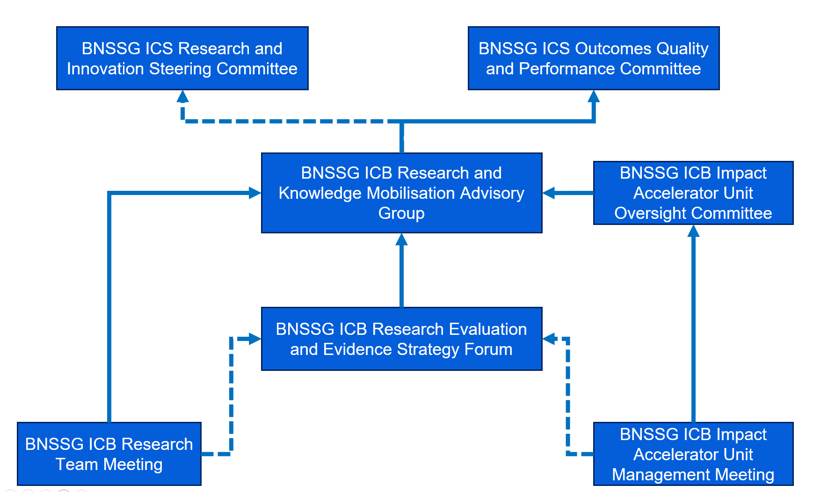
A diagram showing how the governance is structured to monitor research activities.

Conclusion

Implementing this strategy will develop BNSSG ICB from our current position as one of the leading ICBs for supporting research, to having collaboration with academia as a defining feature of how our ICB operates.
There is a requirement from government to increase health and care research activity within the UK, and a commitment to shift health and care services from hospital to community, from analogue to digital and from treatment to prevention. This provides ICBs with a major opportunity to increase their resources available for understanding complex health inequalities within their populations, for delivering innovative projects and for evaluation within their system.
To maximise the benefits of these research opportunities for our population, we need to increase our capacity to apply for and secure external research funding; we need to increase the alignment of our research to our system needs; we need to increase our ability and capacity for embedding evidence into practice; and to make sure this increased activity makes a difference to those who need it most, we need to make sure our research is co-developed with the communities with the greatest health needs, and that participation in research empowers those communities.
Research is a mechanism that effects the trust under-served communities feel for the health and care system. Health and care research that is not actively inclusive and delivered in a trauma-informed, anti-racist way can damage trust through exclusive, extractive and exploitative. It is vital that whilst we grow our research portfolio through this strategy, we raise the standards of research conduct so that best practice is business as usual.
This strategy will give BNSSG ICB the ability to deliver increased value for our population through deeper understanding, innovation and evaluation, and through the normalisation of collaborations with our University partners, it will enrich local Higher Education and contribute significantly to the local economy.
Ultimately, this strategy will deliver health and care research that makes a difference to those who need it most.

References

Baxter H, Bearne L, Stone T, Thomas C, Denholm R, Redwood S, Purdy S, Huntley AL. The effectiveness of knowledge-sharing techniques and approaches in research funded by the National Institute for Health and Care Research (NIHR): a systematic review. Health Res Policy Syst. 2024 Apr 2;22(1):41. doi: 10.1186/s12961-024-01127-5. PMID: 38566127; PMCID: PMC10988883.
Boaz A, Hanney S, Jones T, et al Does the engagement of clinicians and organisations in research improve healthcare performance: a three-stage review. BMJ Open 2015;5:e009415. doi: 10.1136/bmjopen-2015-009415
Connor L, Dean J, McNett M, Tydings DM, Shrout A, Gorsuch PF, Hole A, Moore L, Brown R, Melnyk BM, Gallagher-Ford L. Evidence-based practice improves patient outcomes and healthcare system return on investment: Findings from a scoping review. Worldviews Evid Based Nurs. 2023 Feb;20(1):6-15. doi: 10.1111/wvn.12621. Epub 2023 Feb 8. PMID: 36751881.
Darzi, A. Independent Investigation of the National Health Service in England. September 2024. https://www.gov.uk/government/publications/independent-investigation-of-the-nhs-in-england
Gottlieb ER, Ziegler J, Morley K, Rush B, Celi LA. Assessment of Racial and Ethnic Differences in Oxygen Supplementation Among Patients in the Intensive Care Unit. JAMA Intern Med. 2022;182(8):849–858. doi:10.1001/jamainternmed.2022.2587
Greenhalgh T, Wieringa S. Is it time to drop the 'knowledge translation' metaphor? A critical literature review. J R Soc Med. 2011 Dec;104(12):501-9. doi: 10.1258/jrsm.2011.110285. PMID: 22179293; PMCID: PMC3241522.
Hunn A. (2017) Survey of the general public: attitudes towards health research. Health Research Authority and the National Institute for Health Research. https://research.hscni.net/sites/default/files/HRA_NIHR_general_public_omnibus_survey_2017_FINAL.pdf
Magavern, E, Jacobs, B, Warren, H. et al. CYP2C19 Genotype Prevalence and Association With Recurrent Myocardial Infarction in British–South Asians Treated With Clopidogrel. JACC Adv. 2023 Sep, 2 (7). https://doi.org/10.1016/j.jacadv.2023.100573
NHS England (2023) Maximising the benefits of research: Guidance for integrated care systems https://www.england.nhs.uk/long-read/maximising-the-benefits-of-research/
Ocloo J, Matthews R. From tokenism to empowerment: progressing patient and public involvement in healthcare improvement. BMJ Quality & Safety 2016;25:626-632.
Ozdemir, B. A., Karthikesalingam, A., Sinha, S., Poloniecki, J. D., Hinchliffe, R. J., Thompson, M. M., & Holt, P. J. (2015). Research activity and the association with mortality. PLOS ONE, 10(2), e0118253
Michael Ralph Rees, Martyn Bracewell, On behalf of Medical Academic Staff Committee of the British Medical Association, Academic factors in medical recruitment: evidence to support improvements in medical recruitment and retention by improving the academic content in medical posts, Postgraduate Medical Journal, Volume 95, Issue 1124, June 2019, Pages 323–327, https://doi.org/10.1136/postgradmedj-2019-136501
Wye L, Brangan E, Cameron A, Gabbay J, Klein JH, Pope C. Knowledge exchange in health-care commissioning:case studies of the use of commercial, not-for-profit and public sector agencies, 2011–2014. Health Serv Deliv Res. 2015 doi: 10.3310/hsdr03190. [DOI] [PubMed] [Google Scholar]

