Research Capability Funding (RCF)

Responsive Call

NIHR Grant Preparation

(Type 2)

Guidance for applicants

Supporting research in primary care, community care, public health & social care

Contents

The Responsive Call 3
NIHR Grant Preparation (Type 2) RCF 3
ICB Priorities 10
References 10
Review 10
Eligibility 12
Context of RCF 13
Constraints on Award 13
Reporting and Performance Management 15
Sharing Expertise and Collaborating 16
Deadlines 17
Contacts 17
FAQs 18

The Responsive Call

There will be three Responsive call reviews per year, January, June and October. Exact dates will be advertised on the ICB website.
There are two “types” of Research Capability Funding (RCF) on offer in our Responsive call.
Early Ideas (Type 1) RCF has a set award of £3,000 intended to explore a topic area with all relevant people (stakeholders) and to co-design a specific research question. It is paramount that the population with lived experience are involved in the very start of research question development, in research design, and throughout delivery.
NIHR Grant Preparation (Type 2) RCF has an upper limit of £20,000 which can be used to develop a specific research question into an NIHR grant application. Unfortunately, this does not include Fellowships, but we have other RCF schemes to support this activity.
We encourage Service Led collaborations and NIHR Grant Preparation applications that are ‘service led’ can apply for additional funding up to £10,000. This is because ideas from health and care service colleagues require more time for academic colleagues to familiarise themselves in the topic and establish a viable academic team.
Definition of service led ideas: Service-led research ideas originate directly from frontline service staff, such as those in provider services and health and care planners, rather than being generated by colleagues with an academic role. These ideas are rooted in the practical experiences and needs observed by those directly involved in delivering or designing services, aiming to address real-world challenges and improve service delivery.
Please note that this is a competitive process with limited funds available.

NIHR Grant Preparation (Type 2) RCF

The expectations on recipients of NIHR Grant Preparation awards are to write and submit a research grant application to the NIHR with NHS BNSSG ICB named as the Host (contracting organisation) of the research.
NIHR Grant Preparation awards are intended to support research development activities, and to apply for external NIHR funding to undertake actual/significant research activities. It is not intended that RCF will fund research projects.
Budget
Applications can seek up to £20,000 for NIHR Grant Preparation awards, and should the project be service led (as defined above on page 3) applicants can apply additional funds up to £10,000. A note to applicants: budget limits are not a target to aim for, they are based on reasonable expectations of need to help applicants scale their ambitions for the RCF work.
RCF funds development work of research applications. If the activities you have planned would cost above the expected budget limit, it is likely that RCF is not the right funding source for you, and that RfPB or RPSC would be more suited.
RCF can be sought to apply for the RfPB/RPSC, and we would be pleased to receive applications of this nature.
Legitimate activities
All NIHR Grant Preparation awards should include the time required to write an NIHR grant application. However, to turn an idea for a research project into a viable grant application to the NIHR, some preliminary work may be required, e.g.:
- piloting local data collection*
- analysis of local data*
- stakeholder meetings
- interviews with patients, clinicians and commissioners
- Patient and Public Involvement (PPI) work
- workshops with collaborators.
*Access to system data. If you would like to explore access to routine data, including the linked BNSSG System-Wide Dataset, you will need to contribute some of your RCF budget (£2,500) to the ICB team who process the data and enable your access.

Application form
The NIHR Grant Preparation RCF application form asks applicants to explain:
Element | Why we ask, and what the panel are looking for
1. Project details | Check the Applicant works for an appropriate organisation to receive our RCF (e.g. NHS, HEI, Local Authority, Provider of health &/or Care services), and to log details of the plan for NIHR submission.
2. The project title | If awarded, this title will be used on the ICB website along with the Plain English Summary.
3. Plain English summary | This is a key part of the application for the reviewers to understand the project.  Please use the subheadings provided in the application form. Suggested word limits are also provided in the application form.  For all awarded applications, we will transfer this information on to our website. This is to show internal and external audiences the projects we support with RCF.
4. Barriers and Mitigation to access of the innovation | People with protected characteristics often experience barriers to access for example cultural and language barriers can impede accessibility to research and innovation in diverse populations where health literacy levels, language differences, and cultural perceptions of healthcare vary widely.  BNSSG ICB is committed to reducing inequalities in access, experience and health outcomes. The research we support should aim to contribute to these efforts.  Please describe barriers you have identified and your plans to address these barriers.  By prioritising these strategies, researchers can reduce barriers and foster equitable access, ensuring that the innovation benefits all segments of society, especially those traditionally marginalized.
5. Explain how you have and will continue to work with under-served populations throughout your research project | Research is the ideal tool for tackling difficult and long-standing challenges, and for providing evidence on what the future of health and care delivery should/could be.  The future health and care sector needs to improve services for those populations who have been under-served by current and historical systems.  With that in mind, the ICB has a clear ambition that all research development supported by the ICB should aim to work with under-served populations throughout design and delivery of research.  BNSSG has a wide variety of communities, with obvious inequality. See here for detailed insight into our population.  For Equity provide more information and practical help.  The ICB Research Team can facilitate contact with community groups across BNSSG if you need help making contact.  Please see part one and part two of the NIHR guidance when translation is required.  BNSSG ICB is the proud lead of a Research Engagement Network aimed to increase diversity of participants in health and care research. If you need any help getting started contact bnssg.research@nhs.net.  Please note a guide for increasing diversity in research is provided in the application form.  Independent Patient and Public Involvement (PPI) members and reviewers assessing the projects’ impact on Health Inequalities will assess this section.  Please use the subheadings provided in the application form. A suggested word limit is also provided in the application form.
6. Where & how will your research make a difference? | Considering how the evidence will be used in order to make changes and improvements will help make sure the research is designed appropriately.  Please use the subheadings provided in the application form.  Different types of evidence are more or less impactful in different situations. There is a hierarchy of evidence, and an established belief that the higher the evidence type within the hierarchy (Randomised Controlled Trials (RCTs) are ‘above’ qualitative research) the more useful the evidence will be. But that is not the case in practice. If introducing a new medicinal product, then multiple RCTs systematically reviewed would be required for BNF and NICE approval, prior to changing practice. However, these methods are not only very expensive, they do not produce evidence that is as helpful as qualitative and/or Realist Evaluation methods for decision makers commissioning in a complex health system.  Be sure to explore different methods when designing your research, and have the end user of the evidence in mind, tailoring the methods to meet their needs.
7. Our long-term ambition is for the research supported by BNSSG ICB to over-recruit research participants from under-served populations within BNSSG.  How will you make sure that the eventual NIHR project can contribute to this ambition? | Research is the ideal tool for tackling difficult and long-standing challenges, and for providing evidence on what the future of health and care delivery should/could be.  The future health and care sector needs to improve services for those populations who have been under-served by current and historical systems. We cannot do that unless research evidence is created that proactively seeks to recruit participants for whom the current services don’t work well.  Senior leaders in the NIHR have an ambition that 5% of every research grant will be dedicated funding to Equality Diversity and Inclusion (EDI) activities to increase the representation of under-served populations in the research. The range of expected EDI income per project is therefore from £7,500 for the smallest Research for Patient Benefit grants, to £150,000 for a £3m award.  Traditionally health and care research participants are recruited from services, and by definition this means that under-served populations have not been proportionately represented in research populations and so the evidence is of limited use when planning improvements to services. This is a cycle that could be exacerbating the inequalities. We aim to break this cycle.  The NIHR are seeking to invest in research that tackles these difficult challenges, and we aspire to be a leader in this challenge.  Please see part one and part two of NIHR guidance when translation is required.  Please note a guide for increasing diversity in research is provided in the application form. A suggested word limit is also provided in the application form.
8. Existing Collaborators | The panel want to ensure that RCF is invested in projects that are viable, and having a strong team of collaborators is vital for success with the NIHR. If you don’t have many collaborators yet, the next section is where you can include plans for which roles you would hope to bring in during the RCF period.  Please also list existing Research Engagement Network (REN) and GP Deep End partners in this section.
9. Future Collaborators | The panel and ICB Research Team aim to support applicants to bring in collaborators where they could strengthen an NIHR application. We have an extensive network of colleagues across health & care commissioning, delivery and research, as well as access to health & care system PPI groups.
10. Health inequalities expertise | A combination of experience and training in health inequalities will allow research teams to effectively engage underserved populations and address health inequities throughout research projects.  Please provide details on the team’s experience and training with health inequalities. This could include:  - Training in cultural competence, health literacy, and inclusive research methodologies  - Team members may have successfully conducted projects that emphasize equitable access to healthcare innovations, demonstrating their commitment to reducing disparities and promoting inclusivity in health outcomes.  - The research team may include members with “lived experience”.
11. Budget for your RCF work | Based on previous awards activities we commonly fund with RCF are:  - Grant application preparation and writing  - Patient & Public Involvement (including translation)  - Consumables, travel, transcription, etc.  - Rapid literature review  - Stakeholder engagement  - Pilot aspects of research process in research sites (e.g. General Practices with payments to practice staff)  - Pilot data collection  - Analysis of data  - Access data from the BNSSG system (ICB requires £2,500 contribution for access)  If you require funding for other costs, please add details and brief justification in your application. Please see further guidance here.  Realistically RCF can support up to 3 of the activities listed, as well as PPI, grant application writing & consumables.  This list is here to help you add reasonable costs, and for us to help better manage the finite sum we have available.  Please ensure your costings reflect the actual and accurate costs that will be incurred.  Please note: RCF cannot be used to top-up already funded research grants and cannot be used to fund the delivery of interventions.  Any unused RCF will be reclaimed at the end of the award duration.  RCF funds the development of research applications. If the activities you have planned would cost above the expected budget limit, it is likely that RCF is not the right funding source for you, and that RfPB or RPSC would be more suited.  RCF can be sought to apply for the RfPB/RPSC, and we would be pleased to receive applications of this nature.  Further guidance on NIHR funding streams can be found here.  Please submit costings approved by your finance team with your application. We will not be able to issue outcome letters until costings is provided to us.
12. Declaration and Agreement | This ensures you understand what would be expected from an award of RCF.  We will meet with all awardees to let you know how the research team can help, and what we need in return for RCF awards.  Details on training can be found below within the “Constraints on award” section.

ICB Priorities

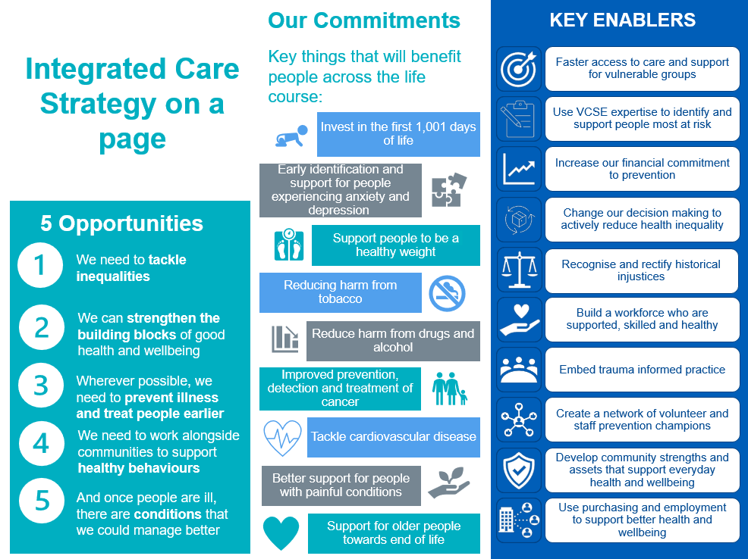

References
References can be supplied, either embedded into the answer, added as a list to the end of the application or as a separate document.

Review
Our aim is to ensure that our RCF investments complement health and care priorities, and that the resultant NIHR submissions are strong and have a good chance of being approved for funding by the NIHR panel.
Process
Step one Remit Check
Our aim is to ensure that our RCF investments compliment health and care priorities, and that the resultant NIHR submissions are strong and have a good chance of being approved for funding by the NIHR panel.
Where the ICB Research Team also search for existing literature and research funding that would make the RCF application unlikely to secure NIHR funding.
The Research Team will also identify appropriate Practitioners for the Practitioner review.
Step two Review
6 Factors will be assessed in parallel, with 5 scored and 1 unscored (as shown below).
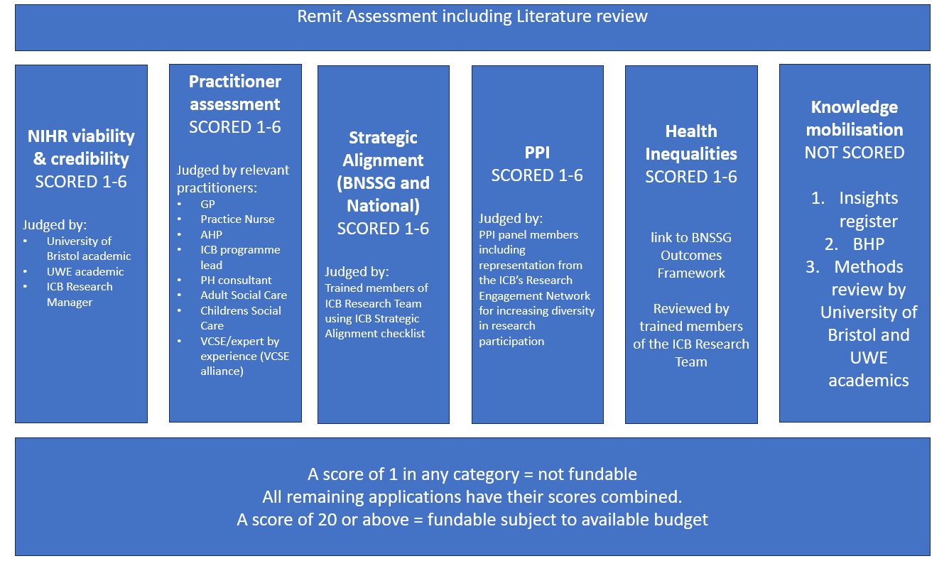
Scoring will be between 1 and 6, from 2 assessors per criterion.

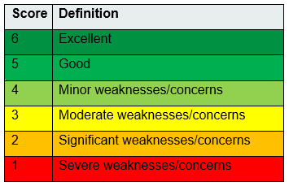
The average scores from each criterion will be combined into a total per application.
If the application scores under 20, it will not be funded. If the application scores 20 or above, it will be recommended for funding, subject to budget.
If an application receives received a score of 1 from any reviewer on any factor it will be rejected.
If there is not enough budget to meet all recommended applications, they will be ranked according to their score and the ICB will award as many as is possible.
If there are multiple applications with the same total score, they are separated by ranking on their individual factor scores, in the following order of priority:
- Practitioner score
- Health Inequalities score
- Strategic Alignment score
- PPI score
- NIHR Viability and Credibility
Panel
The panel consists of:
- Remit is checked by members of the ICB’s Research Team
- Topic relevant ICS Colleagues e.g. Programme Manager or Head of Locality, Public Health Consultant or Head of Adult Social Care at a Local Authority
- PPI representatives
- Bristol Health Partners representative
- Representatives from both the University of Bristol and the University of the West of England (UWE).
Timings
We will review applications three times a year, with deadlines in January, June and October.
We aim to confirm outcomes within 5 weeks of the deadline, however, due to the nature of the bespoke panel members required for the assessment, it may sometimes take longer to obtain outcomes. We will release all outcomes on the same day.
Awardees will be expected to join an online meeting to meet the ICB Research Team, hear about the other RCF awards, and hear what support is available for their projects.

Eligibility
Applications will be eligible if all criteria below are met:
- The lead applicant must be working for an organisation supported by the BNSSG ICB Research Team:
  - Higher Education Institution (HEI)
  - A member organisation of the BNSSG ICS
- The project must be in the area of Primary Care, Public Health, Community Healthcare, Social Care and/or Integrated Care Systems.
- The plan is to develop an idea into an NIHR grant application (not a Fellowship) that will be appropriate for submission to the NIHR with NHS Bristol, North Somerset and South Gloucestershire ICB named as Host (contracting organisation).
Collaborative applications are encouraged, and in particular those that include university staff working in partnership with health & care colleagues.
Strong PPI is essential for all RCF supported projects, and we are looking for planned PPI activities as well as those already completed.
Applications should clearly demonstrate the need for the research, why research is the best choice (as opposed to implementation with evaluation), and clearly present the potential impact for the health & care system.
We strongly encourage applications that have the patient perspective as a clear priority.

This scheme is not intended to support the writing of NIHR Fellowship applications.

Please contact the ICB Research Team directly at bnssg.research@nhs.net if you need support for a Fellowship application.

Context of RCF
NIHR Research Capability Funding (RCF) is a research funding stream made available by the National Institute of Health and Care Research (NIHR) to help research-active NHS organisations attract, develop and retain high-quality research, clinical and support staff.
The ICB’s RCF can be used to free up time to prepare an NIHR grant application, and for pump-priming work to generate preliminary data which will support an NIHR grant application.
This scheme will not fund any activities that do not directly contribute towards an NIHR grant application.

Constraints on Award
Timing
The NIHR RCF is intended to be used within the financial year in which it is issued.
Therefore, we prioritise applications for funding to support work which will start within four months of the submission deadline. The work does not need to have concluded within this same financial year.

Award amount
The £20,000 upper limit for NIHR Grant Preparation awards is not a target to aim for, the amount of funding must be proportionate to the work you intend to undertake, and the work you intend to undertake must be appropriate to the situation.
As guardians of NHS funding, the panel will be judging the appropriateness of the activities listed, and the appropriateness of the associated costs.
The application form will give you an appropriate budget based on the activities you plan to undertake.
We know that working on “service led” applications takes more time, and so these projects are allowed a higher budget limit: an additional amount up to £10,000 can be applied for.
The definition of a service led application is a project that has been initiated by service colleagues reaching out to academic colleagues to support work that is planned/ongoing within the health & care system. Experience shows that there is more groundwork required to get to a viable NIHR application.
You can apply for more funding if you need it, but you will need to provide a strong justification. Our expectation is that if the development work would cost more than the amounts indicated on the application form, then it is probably that other externally funded research budgets would be a more appropriate option for your project (such as RfPB or RPSC). RCF is primarily for grant application writing, with some development work.
BNSSG ICB is committed to increasing research activity within our populations with most need. We are piloting a scheme to help make being involved in research a positive experience for organisations involved in our Research Engagement Network (REN) and GP Deep End Network. We offer additional funding to REN and GP Deep End Network organisations to be used to support any improvement projects.
The funding will be paid to the organisations of existing collaborators involved in the development. If they are lead applicants and from the GP Deep End Network or a REN organisation, the funding is equivalent to 48 hours of a GP/NHS band 8a. If they are collaborators on the application, the funding is equivalent to 16 hours of a GP/NHS band 8a.
Transparency
The spending of government funds must be transparent, and we promote and encourage genuine collaboration and sharing of information.
In line with this, all RCF applicants agree upon submission that if their application is awarded, their name, job title, place of work and a plain English summary of their application will be published on the BNSSG ICB website. This provides transparency on the RCF applications approved by the panel, enables other potential applicants to see what is within our remit, and gives opportunity for potential collaborators to see what work is going on locally.
We will not share the details of unsuccessful applications, but in order to help future applicants, we do publish a list of reasons for rejection provided by the panel.
If you have special circumstances which would make such a publication difficult, please indicate this clearly when submitting your application.
Please do refer to this list before considering applying for RCF.
All RCF awardees will need to report on their spend to the ICB. We will contact recipients for our annual reporting period, and at the end of their RCF duration.
The ICB reports all names and salary details of all RCF recipients to the DHSC as part of our annual finance reporting. This is completed using secure data sharing methods and is a condition of RCF awards.

Training obligations
BNSSG ICB is proud to be a leading a Research Engagement Network, which is committed to increasing the diversity of participants in research. We have learned a lot from our local community members, and as part of a national peer network led by NHS England.
One clear need is that all researchers working with communities need support to be “community ready” and for our research to make the impacts we all want to see, we need to ensure research is developed with equality, diversity and inclusion at the forefront of activities, as well as colleagues supported to understand anti-racism and cultural humility.
As such, all recipients of RCF will be expected to undertake training on these elements, or to show evidence of having been on training within the preceding 24 months.
The plan is to develop face to face training which will be delivered by some of our partners Voluntary, Community or Social Enterprise organisations based within BNSSG. In the meanwhile, the training expected of RCF recipients are below:
https://www.e-lfh.org.uk/programmes/cultural-competence/
and
https://www.england.nhs.uk/about/equality/equality-hub/national-healthcare-inequalities-improvement-programme/contacts-and-resources/training/
Evidence of completion (or equivalent training) will be required for the final payment of the RCF award.

Reporting and Performance Management
All projects funded through this call will be supported and monitored by the ICB Research Team.
The ICB Research Team approach is that we are partners working to support RCF recipients to maximise their chances of success with the NIHR. Whilst we will work with you to make progress, as guardians of NHS funds the ICB retain the right to withdraw or curtail funding if progress is not satisfactory.
A member of the ICB Research Team will contact each recipient of RCF to agree a plan of progress with, if appropriate, performance indicators which will signify success for their RCF funded work.
At the end of each financial year, a report will be required of each recipient of RCF. This information will contribute to the ICB’s report to the DHSC on our RCF spend.
All RCF recipients will also be required to produce a final report at the end of their funding. For the final payment of RCF NIHR Grant Preparation awards an end of award report as well as a final statement of expenditure will be required along with the evidence of completion of training as described in training obligation section above.
All NIHR grant applications resulting from work funded by this scheme must be submitted with NHS Bristol, North Somerset and South Gloucestershire ICB named as grant Host (contracting organisation).
Work funded by ICB RCF should start within 5 months of notification, and if the project has not started within 6 months, funding may be withdrawn.
Applicants must seek input from the Research Support Service, or from a registered Clinical Trials Unit (as appropriate) to support their research design (post award of RCF, not prior to your RCF application).
Recipients of RCF will be contacted regularly to review progress and for the ICB Research Team to provide appropriate support. The ICB Research Team are here to help ensure applications submitted to the NIHR are of the highest possible quality. We collate feedback from the NIHR on previous applications to help improve future submissions, and would also value your feedback on what would have been helpful, that we can look to introduce for future recipients of RCF.
You can contact the ICB Research Team at any time if you have any queries, or would like some support with any aspect of preparing a grant application. We encourage all RCF recipients to contact us as soon as there is a query or issue. Because we work on so many grant applications, the query or issue is often something we have dealt with several times previously.
Our main aim is to help make your NIHR application as good as it can be.

Sharing Expertise and Collaborating
NHS Bristol, North Somerset and South Gloucestershire ICB is committed to the production of research relevant to health and social care.
As part of our ongoing drive to increase collaborations between researchers and healthcare professionals, a condition of acceptance of all RCF awards is that applicants will be willing to spend up to 6 hours over the lifetime of the award, or within 12 months post-completion of the award, working closely with local commissioners.
This may take the form of:
- offering general advice,
- inputting research evidence into business cases,
- delivering presentations, such as an ICB seminar,
- meeting with commissioners to discuss their interests, or
- suggesting possible evaluation approaches.

You will be contacted by the ICB Research Team if commissioners indicate that your skills and experience would be useful in this way.

Deadlines
Electronic submission of form (email attachment) to bnssg.research@nhs.net will be accepted throughout the year.
We will acknowledge receipt of your email.
See our website or the latest information on deadlines.
We plan to hold panel reviews in June, October and January each year. These timings are depending on available budget.

Contacts
We are always happy to speak through any questions applicants may have. Please contact the BNSSG ICB Research Team, relevant contacts for your organisation are below:
 | For applicants outside of UWE Bristol, please contact the Research Team  bnssg.research@nhs.net
 | Dr Alison Diaper  Senior Research Fellow  0117 32 832341  alison.diaper@uwe.ac.uk

Areas of Research Interest (ARIs) are specific topics or issues that the government is interested in.
They are a way for government organisations to indicate that they’re keen to hear research evidence or insights related to that area.
ARIs are wide-ranging and can cover anything from economic and social policy to international relations and national security. By identifying ARIs, the civil service can ensure that research efforts are targeted where evidence is most needed to inform policy decisions and improve government performance.
ARI Database | Search, browse or analyse Areas of Research Interest (ARIs) from UK governmental bodies.

FAQs
I already know what research question I want to investigate. Can I apply for an NIHR Grant Preparation (Type 2) without having received an Early Ideas (Type 1) award?
Yes: Applicants can submit a NIHR Grant Preparation application if they have already identified a specific question to investigate. However, the panel are charged with supporting research which is co-developed with NHS and/or Local Authority colleagues and with strong PPI. Applicants who choose to opt out of the co-development period Early Ideas will have to demonstrate strong collaboration with health & care and PPI partners. The panel may recommend funding an Early Ideas award if the project is strong on other elements but is deemed in need of stronger PPI to design the RCF work.

I have developed several ideas from an Early Ideas award. Can I submit more than one NIHR Grant Preparation applications from a single Early Ideas award?
Yes absolutely: We hope that Early Ideas awards will identify several research questions. We will be open to receiving as many as the applicant wishes to submit. If there are a high number of ideas, it would be wise to prioritise with the collaborators as the main limiting factor will be the applicants’ time available to dedicate to writing NIHR applications. We are happy to help prioritise if you would like our input on this.
Further, there may be ideas for improvements that do not require research and could be enacted if the information was provided to the right team within the health system. The ICB Research Team are here to deliver this. Please highlight any and all learning to the ICB Research Team.

Can I defer an NIHR Grant Preparation application from an Early Ideas award?
The intention is that each recipient of an Early Ideas award will submit at least one NIHR Grant Preparation application within 12 months. However, should several potential research ideas develop from an Early Ideas award, we would have an open door policy, and welcome further NIHR Grant Preparation applications at any/all subsequent RCF calls.

Do I need to have completed a costing at my University before submitting an RCF application?
Yes, an approved costing is expected to be provided with your application and the finance officer will need to sign your application.

What are the panel looking for in an Early Ideas application?
The panel are looking to invest in developing research in areas of importance to the healthcare system. All areas of healthcare are important to those affected by the particular condition, as a health commissioning organisation we need to be convinced that the topic area:
- is within the remit of BNSSG ICB research – primary care, community care, social care, public health, integrated care and population health management.
- is of strategic importance i.e. a published priority of Healthier Together, NHS England, one of our Locality Partnerships and/or a BNSSG Local Authority.
- has clear potential to increase health within existing budgets, and/or
- has clear potential to reduce spending within the health system without decreasing patient outcomes and/or experience.
- will not exacerbate health inequalities.
What are the panel looking for in an NIHR Grant Preparation application?
The panel are looking to invest in projects which:
- are within the remit of BNSSG ICB research – primary care, community care, social care, public health, integrated care and population health management.
- are within the remit of an NIHR funding stream and have a strong chance of securing NIHR funding:
  - appropriate Chief Investigator
  - viable project
  - proof of concept
  - will produce useful evidence for the health &/or care services.
- make a convincing case that they will be feasible
- have genuine co-development in a) planning development activities, b) identifying issues of concern, c) generating potential solutions, d) planning the research methodology, and e) planning the dissemination and implementation of the findings
- will produce results of real value to the users of evidence within the healthcare system. Factors which will be considered include:
  - the timing of the delivery of the results (will the issue still be an issue when the final report is published?)
  - balance of robust vs pragmatic approaches
  - outcomes which are meaningful to the evidence users
  - results that could lead to viable changes in the delivery of health and care services.
  - Project aligned to our ICP system priorities
Do I need to submit both an Early Ideas and an application for an NIHR Grant Preparation submission?
No. This was the case with our first two rounds of our revised RCF format (in 2019) but following feedback we amalgamated questions so that you only need to complete 1 form per submission: either an Early Ideas or NIHR Grant Preparation application form.
Does NIHR Grant Preparation application includes costs of writing Stage 1 and Stage 2 NIHR applications?
Yes, NIHR Grant Preparation applications are expected to include costs of writing both Stage 1 and Stage 2 NIHR applications. Award holders will need to ensure that some of the funding is retained for Stage 2 submissions. If application is unsuccessful and not invited to Stage 2, we expect these funds to be returned to us.

