Trauma Impact Assessment Tool
This Trauma Impact Assessment Tool has been designed by the BNSSG Trauma-Informed Systems Programme to support you to consider where trauma may exist in relation to your work programme, project or policy and to identify what steps you can take to reduce negative impacts.

Trauma and Trauma-Informed Practice
“Trauma results from an event, series of events, or set of circumstances that is experienced by an individual as harmful or life threatening. While unique to the individual, generally the experience of trauma can cause lasting adverse effects, limiting the ability to function and achieve mental, physical, social, emotional or spiritual well-being.” (Working definition of trauma-informed practice - GOV.UK)
This tool promotes an ongoing and active commitment to trauma-informed practice.
Trauma-informed practice realises that experiences of trauma are common within our society and recognises the ways that this can impact people. Being trauma-informed involves resisting causing any further harm or distress to people by responding to people's trauma in a way that is compassionate, supportive and helps people not feel shame or judgment around their experiences and how they have survived them. Relationships, including those that we have within our staff teams, can create a sense of belonging, safety and connection to others which can be healing for people who have experienced trauma.
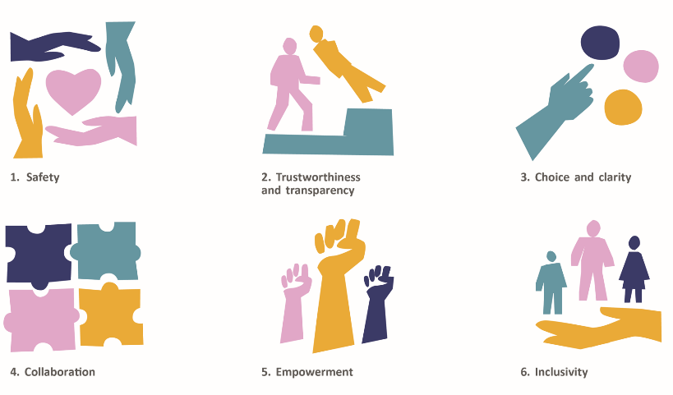
The principles that underpin a trauma-informed practice are safety, trustworthiness and transparency, choice and clarity, collaboration, empowerment and inclusivity.
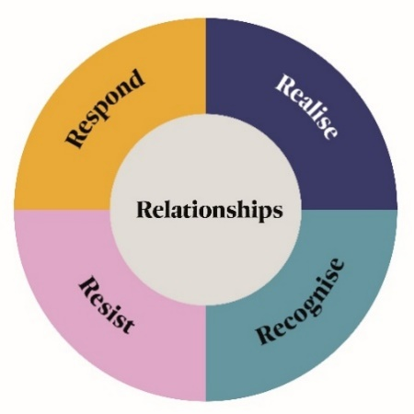

Experiences of trauma are common and can take place across any part of someone’s life. Individuals, families, carers, communities and the workforce may have past experiences of trauma that can be compounded by interactions or contact with services or different parts of our system. Experiences of trauma can influence how we interact with others, how we interpret our surroundings and the world around us and how we access, engage with and experience services. While trauma can affect anyone in our population, people living in areas of deprivation, or who already experience health and social inequalities or multiple disadvantage, or who are within inclusion health groups, are more likely to experience trauma in their lives.
We recommend that this assessment tool is completed alongside others such as Quality Impact Assessments, the Health Equity Assessment Tool (HEAT) or Equality & Health Inequality Impact Assessment (EHIA) and that experiences of trauma are considered within these.
For more information on trauma-informed practice and how to implement this into practice please refer to the BNSSG Trauma-Informed Practice Framework.

- Context
Please provide a brief description of your programme, project or policy including who is involved and intended outcomes
- Impact
What do you already know about experiences of trauma that may be impacting your population group.

Please give consideration to social political and cultural contexts and how these may intersect.

Please describe where this knowledge has come from (eg service user/ patient stories or feedback, professional expertise, data, academic literature, research and evaluation findings)

How will you acknowledge the impact of trauma for your staff?

How will staff be supported around this to reduce the risk of negative impact (e.g. secondary or vicarious trauma, burnout or moral injury) and to improve wellbeing?

How do you expect your programme, project or policy will impact (positively or negatively) on feelings of safety for those involved?

What steps will you take to maximise feelings of physical, psychological and emotional safety?

Please describe how you intend to engage with individuals, families, carers and communities and build ongoing co-production into your delivery.

What steps are you taking to ensure that seldom heard voices and marginalised groups and communities are being listened to and included?

How do your plans build on the strengths, resources and assets of those involved (individuals, families, carers, communities and the workforce)?

How is this reflected in the language you use?

What steps are you taking to identify the trauma of discrimination and experiences of multiple disadvantage and inequality? (e.g. poverty or racism)

How are you seeking to understand the different cultural perceptions of trauma and adapting your support to incorporate these?
- Ongoing development and next steps

How will you monitor and evaluate the impact of your programme, project or policy on different population groups in relation to trauma?
What will you do differently to drive improvements in your programme, project or policy in relation to trauma?

What actions or changes can you identify?

Review date
Lead contact

