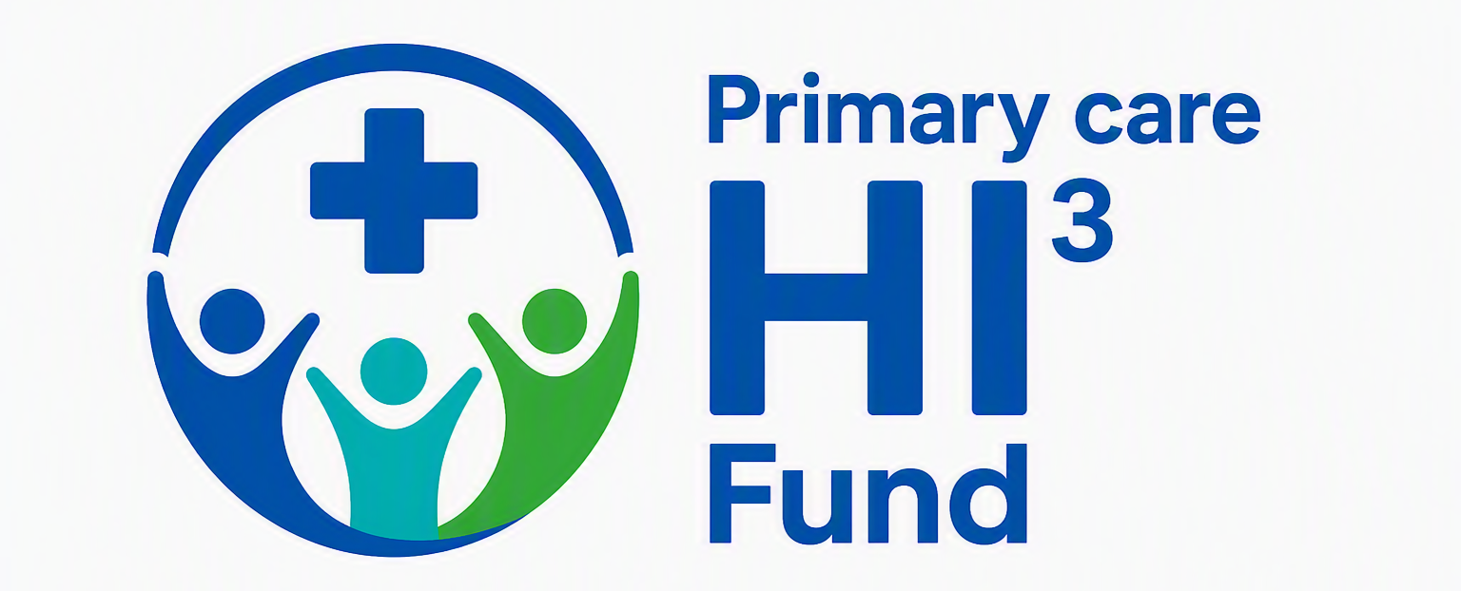
Application Form
Any wording beyond the stated word limit will not be considered as part of the application.
Section 1 – Project Details

Project Title (Word Limit: 20 words)

2. Lead Applicant
Applicant’s name:
Job Title:
Department/Organisation:
Email:
Telephone:

3. University of Bristol Co-Applicant (can be same as above named applicant)
Applicant’s name:
Job Title:
School/Department:
Email:

3. Primary Care Collaborator
All applications must include at least one named primary care collaborator (can be same as above named applicants)
Applicant’s name:
Job Title:
Organisation:
Email:

Section 2 – Project Summary

2.1 Plain English Summary (Word Limit: 250 words)
Please describe your project in language suitable for a non-specialist audience.

2.2 Funding Requested

Section 3 – The project

3.1 What problem are you trying to address?
Please describe:
- The issue or unmet need
- Who is affected
- Why action is needed now
- Any evidence supporting this need
Maximum 500 words

3.2 What service improvement or evidence implementation activity do you propose?
Please describe:
- The intervention or improvement
- The evidence informing the approach
- What will be different as a result of the project
Maximum 500 words

3.4 Project Plan
Please provide a summary timetable.
Project Start
Mid-point review
Delivery complete
Evaluation complete
Final report submitted

  - Strategic Alignment
Please highlight which local and/or national health system priorities your project supports (bullet points referencing priorities encouraged).
Maximum 250 words

3.6 Sustainability
Please describe:
- How activity will continue after funding ends
- How ongoing costs will be met
- Any workforce, maintenance or operational requirements
Applications requesting equipment should explain:
- Ownership arrangements
- Maintenance requirements
- Consumable costs
- Replacement plans
Maximum 500 words

3.7 Potential for Spread
Please describe how the learning, improvement or intervention could be adopted elsewhere within G+BNSSG.
Maximum 300 words

3.8 Evaluation Plan
Please describe:
- What success looks like
- What outcomes will be measured (qualitative measures are welcome)
- How data will be collected
- How learning will be captured
- The role of the University of Bristol partner
Maximum 500 words

3.9 Key Risks and Mitigations

Risk | Likelihood (L/M/H) | Impact (L/M/H) | Mitigation

Section 4 –Inequalities and inclusion

4.1 Addressing Health Inequalities
Please explain:
- Which population groups will benefit.
- How inequalities have influenced project design.
- How the project may reduce health inequalities.
Maximum 500 words

4.2 Digital Inclusion
Please explain:
- Whether the project includes a digital element
- Any potential barriers relating to digital access
- How digital inequalities have been considered and mitigated
Maximum 500 words

4.3 Patient and Public Involvement and Engagement (PPIE)
Please describe:
- If PPIE has been involved in developing the proposal
- How patients, service users or communities will be involved during implementation and delivery
- How patient and public feedback will influence the project
Maximum 500 words

Section 12 – Budget

12. Please provide a summary budget.

Cost Category | Amount (£)
Staff Salary/Backfill
Project Delivery Costs
Equipment
Patient and Public Involvement
Evaluation
Other
Total Requested

12.1 Equipment Justification
Complete only if equipment costs are requested.
Please explain:
- Why the equipment is required
- Future ownership arrangements
- Maintenance arrangements
- Consumables and replacement costs
Maximum 300 words

12.2 Evaluation Costs
Please confirm that evaluation costs do not exceed 20% of the total funding request.

☐ Confirmed

Section 13 – Eligibility Confirmation

13. By submitting this application, the lead applicant confirms that:
The lead organisation is based within BNSSG
The project primarily benefits BNSSG residents.
The project focuses on and invests in primary care.
A University of Bristol co-applicant is included.
A named primary care collaborator is included.
The project duration does not exceed 24 months.
Funding is not being requested for indirect costs or organisational overheads.
Any equipment request includes a sustainability plan.
Patient and public involvement is included.
An evaluation plan is included.

Section 14 – Declaration

14. Declaration and Agreement
I confirm that the information provided in this application is accurate to the best of my knowledge.
I understand that:
- Funding decisions are final.
- There is no appeals process.
- Applications will be assessed in accordance with the published guidance.
- Successful projects will be required to submit monitoring information and a final evaluation report.
Signature of lead applicant |  | Date

Attachments Required
Applicants must submit:
- Completed application form.
- Detailed budget spreadsheet (please email bnssg.research@nhs.net for any queries)

Provide your feedback on BizChat

